**DEVOPS**

**DevOps lifecycle**

The various phases of the DevOps lifecycle are as follows:

Plan - Initially, there should be a plan for the type of application that needs to be developed. Getting a rough picture of the development process is always a good idea.

Code - The application is coded as per the end-user requirements.

Build - Build the application by integrating various codes formed in the previous steps.

Test - This is the most crucial step of the application development. Test the application and rebuild, if necessary.

Integrate - Multiple codes from different programmers are integrated into one.

Deploy - Code is deployed into a cloud environment for further usage. It is ensured that any new changes do not affect the functioning of a high traffic website.

Operate - Operations are performed on the code if required.

Monitor - Application performance is monitored. Changes are made to meet the end-user requirements.

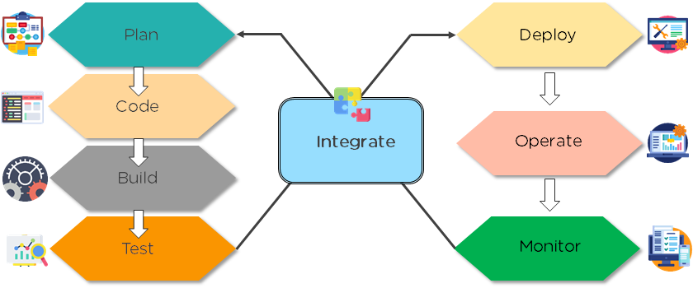

**How is DevOps different from agile methodology?**

[DevOps](https://www.simplilearn.com/tutorials/devops-tutorial/what-is-devops) is a culture that allows the development and the operations team to work together. This results in continuous development, testing, integration, deployment, and monitoring of the software throughout the lifecycle.

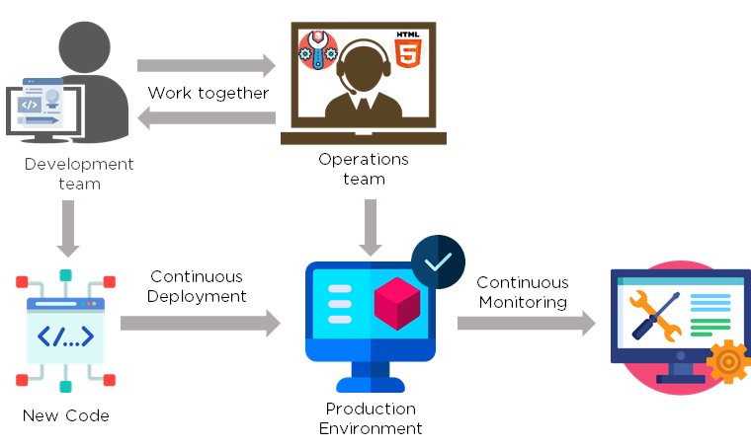

[Agile](https://www.simplilearn.com/tutorials/agile-scrum-tutorial/what-is-agile) is a software development methodology that focuses on iterative, incremental, small, and rapid releases of software, along with customer feedback. It addresses gaps and conflicts between the customer and developers.

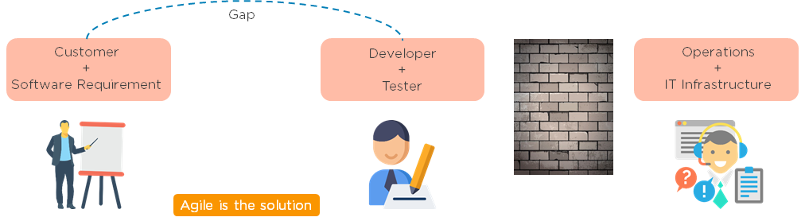

DevOps addresses gaps and conflicts between the Developers and IT Operations.

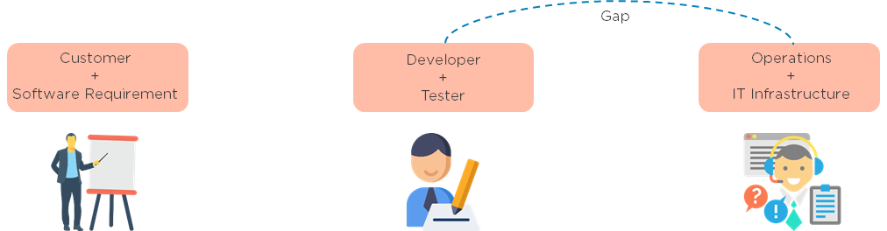

**Jenkins Tool**

**Jenkins configurations path**

cd /etc/default/

Vi Jenkins

**To change default pot in simple way**

sudo iptables -A PREROUTING -t nat -i eth0 -p tcp –dport80 -j REDIRECT –to-port 8080

sudo sh -c “iptables-save> /etc/iptables.rules”

**To enable sudo acces for Jenkins**

Sudo visudo -f /etc/sudoers

In this file add below line

Jenkins ALL=(ALL) NoPASSWD:ALL save the file then run the restart command

Service Jenkins restart then next go to Jenkins and run build

**Explain the difference between Continuous Integration, Continuous Delivery, and Continuous Deployment? ( CI CD CD)**

**Answer:**

Continuous integration: (CI) (code integration will be done when code is push to the git it will take from it.)

It is the process of constantly integrating the changes into the main software during all the stages of the delivery pipeline, once the changes are tested on the test environment. CI can also be referred to as the work done by the Jenkins or Bamboo server.

Continuous delivery: (CD) will be ready the software

It is the delivery of code (shipping) to a particular environment like test, integration or production through a manual release.

Continuous deployment: (CD) will not be done frequently in production

It is the automatic release of code into the staging or production environment, once the testing is done in the CI stage.

**Question: Describe Continuous testing.**

**Answer:**In continuous testing, feedback is received at each stage of the continuous delivery pipeline. It helps to improve code quality by running the automated test cases over and again. It also reduces the code and testing cycles, ensuring stable builds are available in less time, thus optimizing the testing process.

### **/var/folders/5p/2y18nqx52pj_2x1_cpz7plwm0000gn/T/com.microsoft.Word/WebArchiveCopyPasteTempFiles/continuos_delivery_continuos_deployment.png**

**Build Triggers**

Mostly we use

GitHub hook tigger for GITScm polling – when code changes in git it will send to the Jenkins in jenkins its runs deployment

when we need frequently deployments then we will use github hook

Pool SCM – we can use as a schedule deployments with using cron jobs as per the project requirements like 3 days or weekly

#### ****Question: How can you create a job?****

**Answer:** On the dashboard page, you can just select a ‘New Job’. When you create a job, you can choose options such as the SCM, triggers to control, the build script and notifications.

### **How can you setup Jenkins jobs?**

Follow these steps:

* Select new item from the menu.
* After that enter a name for the job and select free-style job.
* Then click OK to create new job in Jenkins.
* The next page enables you to configure your job.

**Question: Have you created a build job in Jenkins? Explain how to do it.**

**Answer:** Yes. The simple steps are –

* Click on New Item on the Dashboard.
* Select the freestyle project option
* Specify the details of the job like SCM, build triggers, advanced options etc…
* It is important to specify the location of files that should be built.
* Once all the settings are marked, click on ‘Add build step’ and select the appropriate option. For example, if you want to build a file, select the file name along with the build command.
* Click on Build now for saving the build and doing a test run.

#### ****Question: Explain the process of setting up a Jenkins job?****

**Answer:** Jenkins handles project builds through jobs. To set up a job, you should follow a few steps:

* Select a new item, and enter the name of the job.
* Select freestyle project and press OK.
* Enter the job description and configure the number of builds and time for which they should be retained.
* Configure the repository (Example Git). Enter the URL and credentials.
* Specify the build triggers.
* Save the job.
* Validate the job by clicking on ‘Build Now’.

**What are the types of pipelines in Jenkins?**

Answer: There are 3 types –

CI CD pipeline (Continuous Integration Continuous Delivery)

Scripted pipeline

Declarative pipeline

**Question: Explain the process of creating the Multibranch Pipeline in Jenkins?**

**Answer:**The process is as follows:

* Open the Jenkins dashboard and create a new item by clicking on ‘new item’ from the top left menu.
* Enter your project name and from the options shown, select ‘Multibranch pipeline’ and click on OK.
* Then you should select the repository location, branch source (GitHub/Bitbucket), and add the credentials of the branch source.
* Save the project.
* Jenkins automatically creates new Multibranch Pipelines for repositories that have branches and pulls requests containing Jenkins files.
* To connect to the GitHub repo, we need the HookURL. Get this URL from the repository settings.
* Add this HookURL to the Webhooks section.
* Once the jobs are created, build is automatically triggered by Jenkins.

**Creating your first Jenkins pipeline.**

**Step 1**: Log into Jenkins and select ‘New item’ from the dashboard.

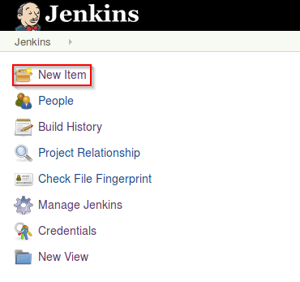

**Step 2**: Next, enter a name for your pipeline and select ‘pipeline’ project. Click on ‘ok’ to proceed.

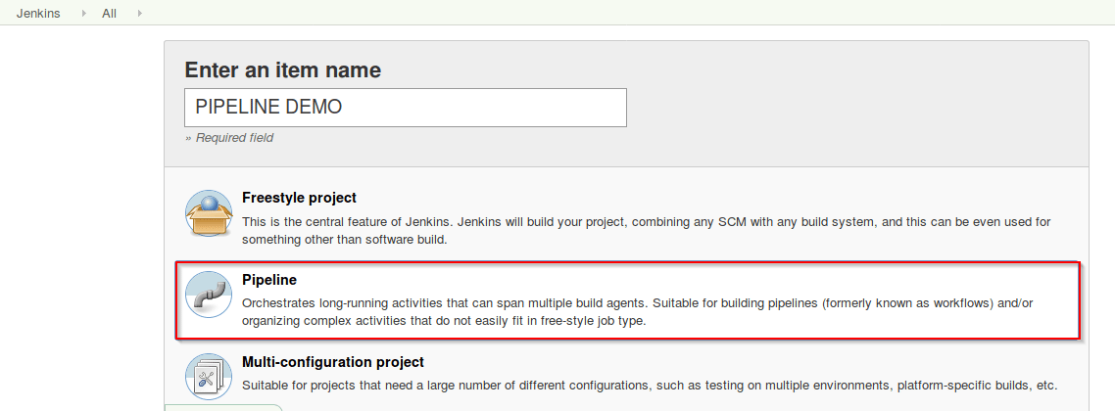

**Step 3**: Scroll down to the pipeline and choose if you want a declarative pipeline or a scripted one.

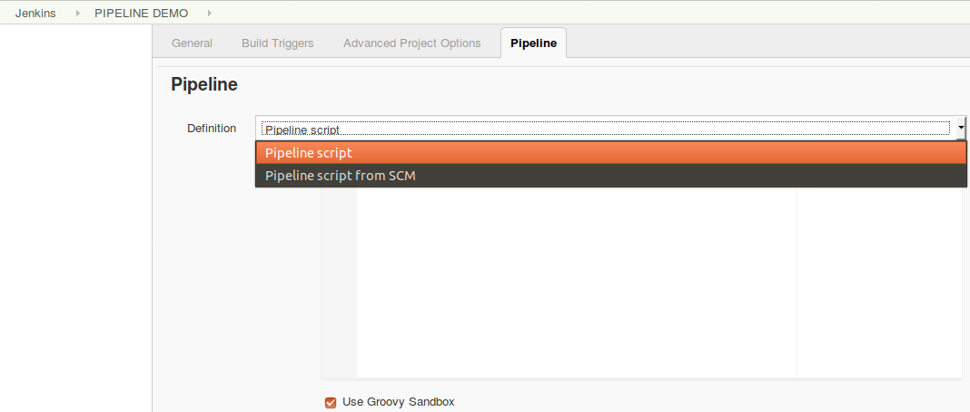

Declarative or scripted pipeline – Jenkins Pipeline Tutorial

**Step 4a**: If you want a scripted pipeline then choose ‘pipeline script’ and start typing your code.

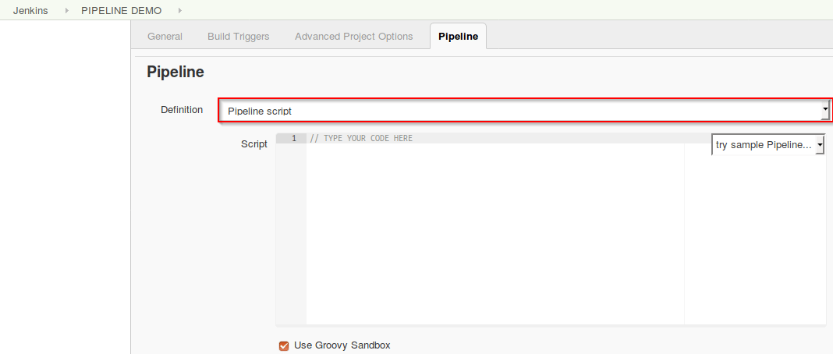

**Step 4b**: If you want a declarative pipeline then select ‘pipeline script from SCM’ and choose your SCM. In my case I’m going to use Git throughout this demo. Enter your repository URL.

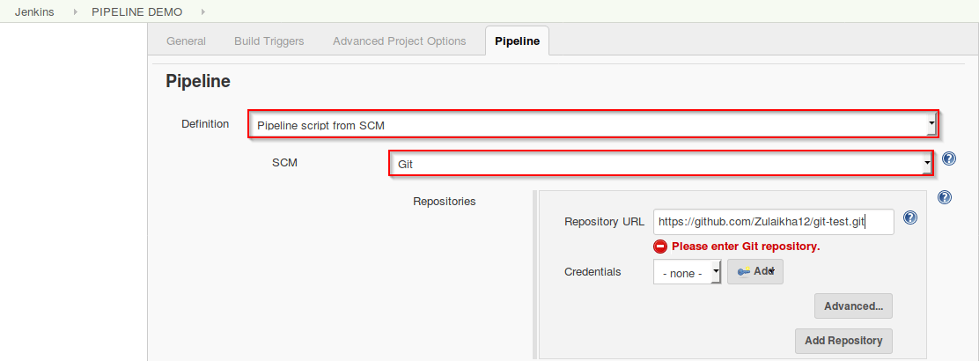Declarative

**Step 5**: Within the script path is the name of the Jenkinsfile that is going to be accessed from your SCM to run. Finally click on ‘apply’ and ‘save’. You have successfully created your first Jenkins pipeline.

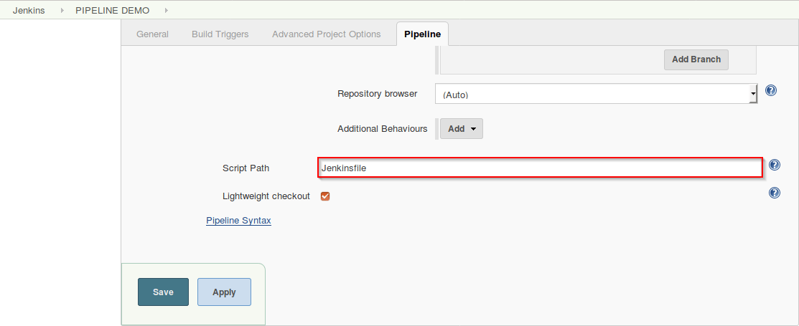Script path – Jenkins Pipeline Tutorial

Now that you know how to create a pipeline, lets get started with the demo.

### **Scripted Pipeline Demo**

To give you a basic understanding of the scripted pipeline, lets execute a simple code. Refer to [Creating your first Jenkins pipeline](https://www.edureka.co/blog/jenkins-pipeline-tutorial-continuous-delivery#Createpipeline) to create the scripted pipeline. I will run the following script.

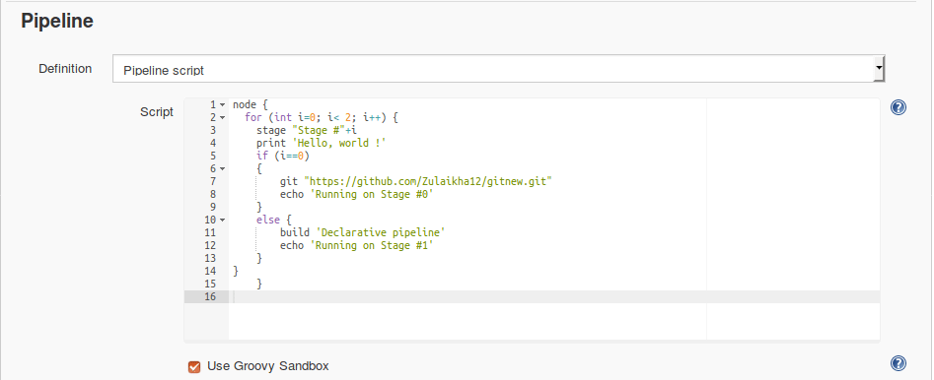

Pipeline script – Jenkins Pipeline Tutorial

``

**Jenkins Scripted Pipeline example- with groovy syntax**

**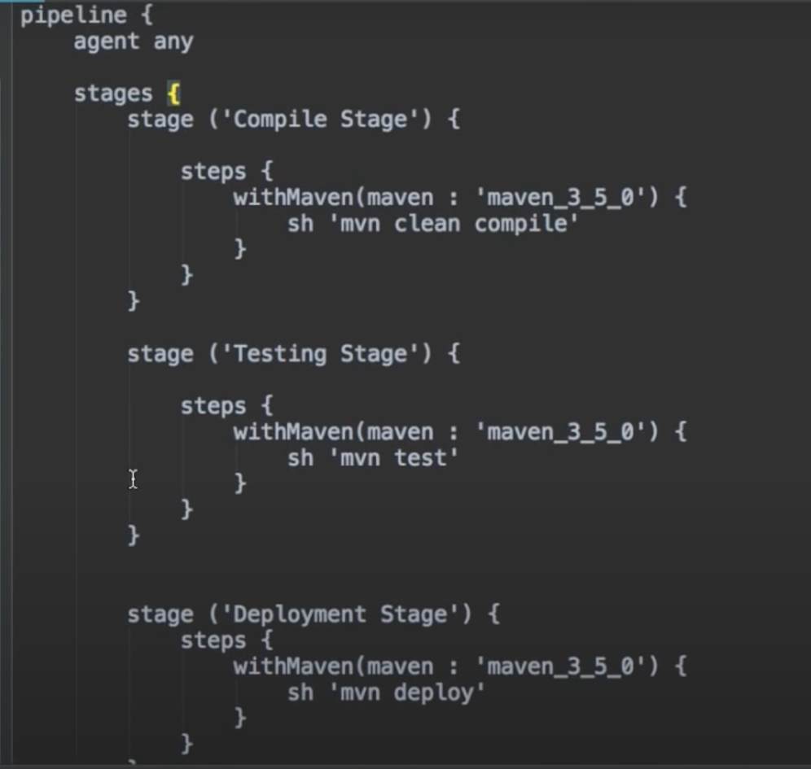**

|  |
| --- |
| pipeline { |
|  | agent any |
|  | stages { |
|  |  |
|  | stage('Clone Repo') { |
|  | steps { |
|  | sh 'rm -rf pipelinetesting\_master' |
|  | sh 'rm -rf pipelinetesting' |
|  | sh 'git clone https://github.com/mavrick202/pipelinetesting.git' |
|  | } |
|  | } |
|  |  |
|  | stage('Build Docker Image') { |
|  | steps { |
|  | sh 'cd /var/lib/jenkins/workspace/pipelinetesting\_master' |
|  | sh 'docker build -t sreeharshav/pipelinetestmaster:${BUILD\_NUMBER} .' |
|  | } |
|  | } |
|  |  |
|  | stage('Push Image to Docker Hub') { |
|  | steps { |
|  | sh 'docker push sreeharshav/pipelinetestmaster:${BUILD\_NUMBER}' |
|  | } |
|  | } |
|  |  |
|  | stage('Deploy to Docker Host') { |
|  | steps { |
|  | sh 'docker -H tcp://10.1.1.100:2375 stop masterwebapp1 || true' |
|  | sh 'docker -H tcp://10.1.1.100:2375 run --rm -dit --name masterwebapp1 --hostname masterwebapp1 -p 8000:80 sreeharshav/pipelinetestmaster:${BUILD\_NUMBER}' |
|  | } |
|  | } |
|  |  |
|  | stage('Check WebApp Rechability') { |
|  | steps { |
|  | sh 'sleep 10s' |
|  | sh ' curl http://10.1.1.100:8000' |
|  | } |
|  | } |
|  |  |
|  | } |
|  | } |

**Multibranch pipline**

pipeline {

agent any

stages {

stage('Build') {

parallel {

stage('Build') {

steps {

echo 'Building..'

sh 'hostname'

sh 'pwd'

sh 'ls -al && hostname && pwd && cat /etc/passwd'

}

}

stage('error') {

steps {

sh 'ls -al'

}

}

stage('teststage') {

steps {

sh 'ls -al'

}

}

}

}

stage('Test') {

parallel {

stage('Test') {

steps {

echo 'Testing..'

}

}

stage('error') {

steps {

sleep 10

}

}

}

}

stage('Deploy') {

steps {

echo 'Deploying....'

}

}

}

}

**Docker file**

FROM nginx:latest

MAINTAINER mavrick202@gmail.com

COPY index.html /usr/share/nginx/html/

COPY scorekeeper.js /usr/share/nginx/html/

COPY style.css /usr/share/nginx/html/

**Arthei.pk@tcs.com**

**Jenkins Web Free style Project (web server build)**

**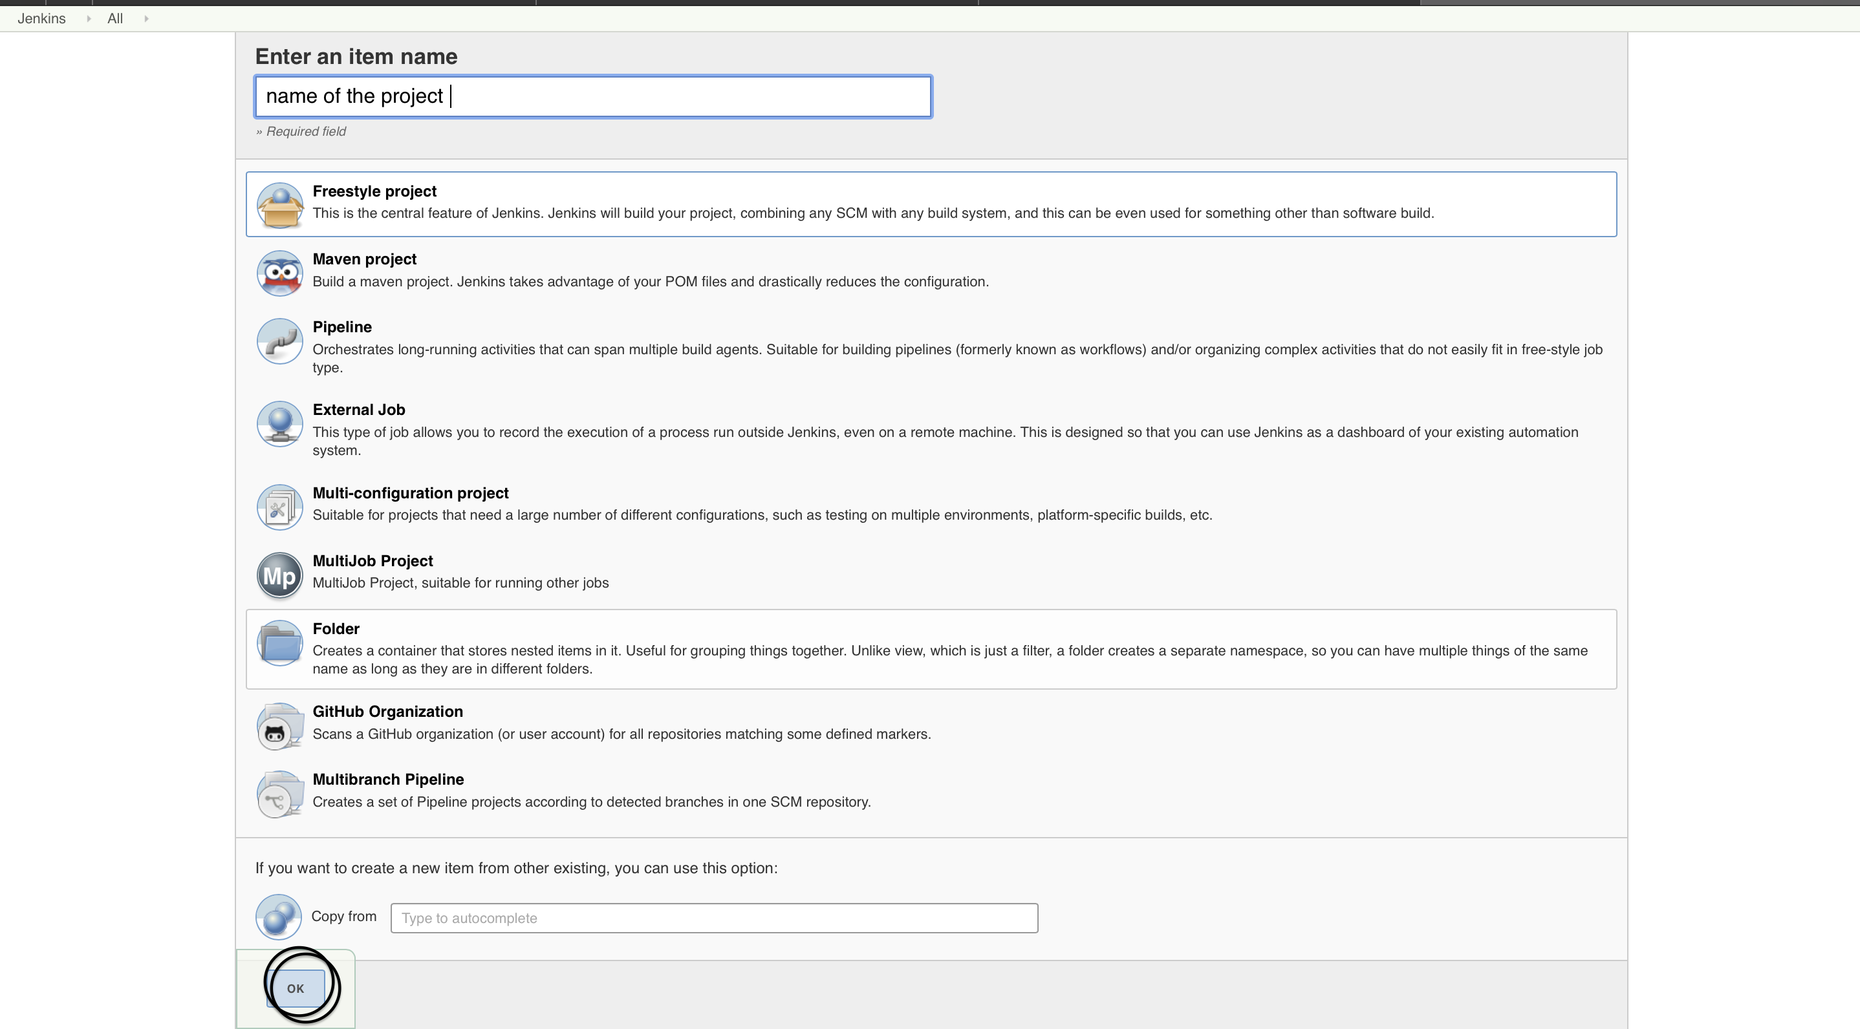**

**General**

**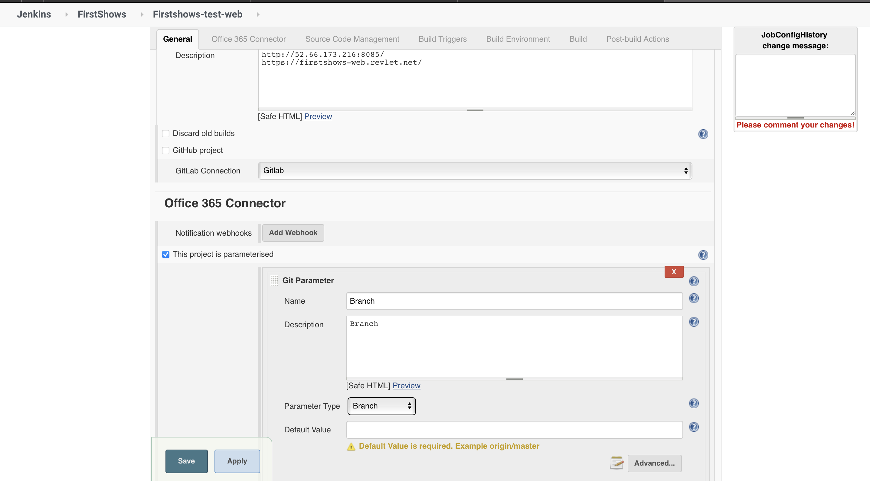**

**Office 365 connector**

**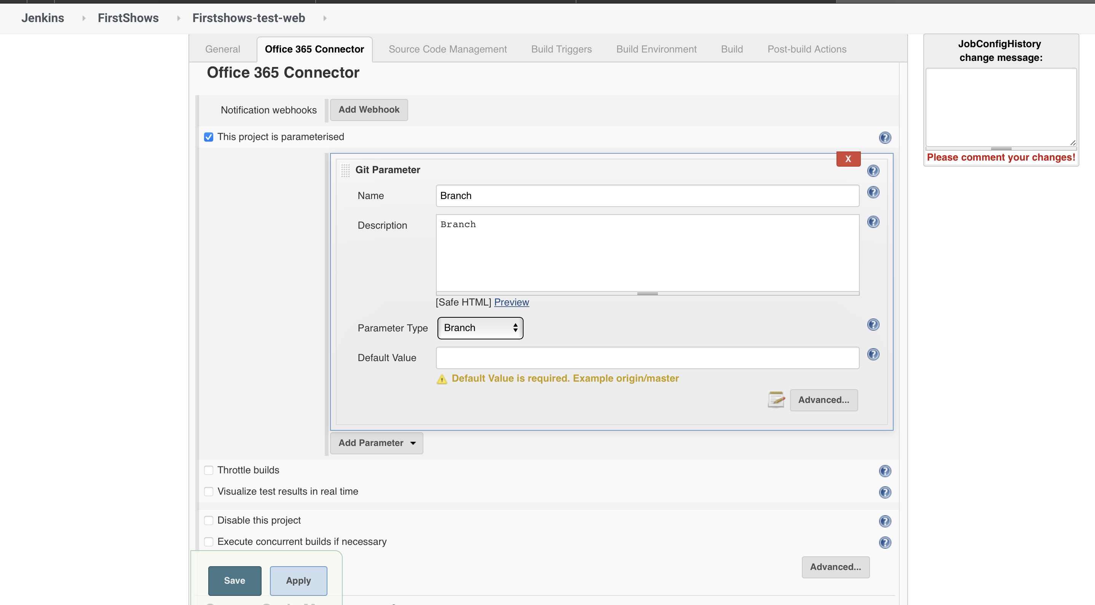**

**Source Code Management**

**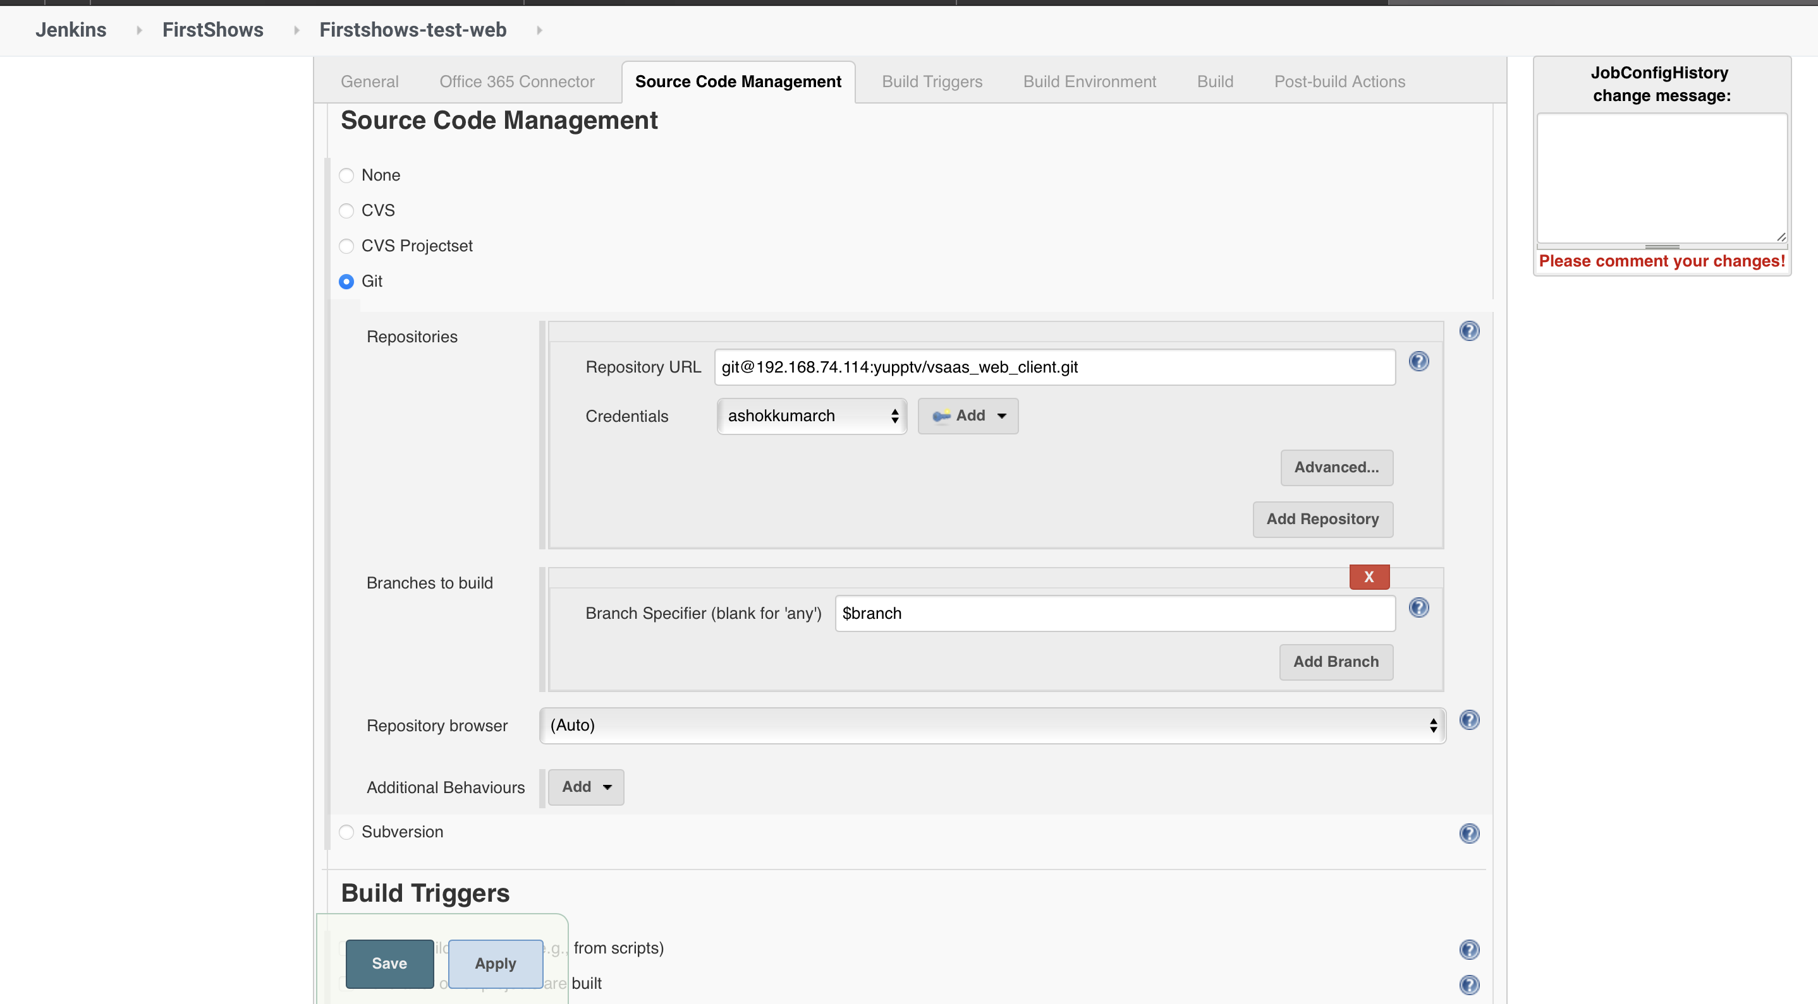**

**Build Triggers**

**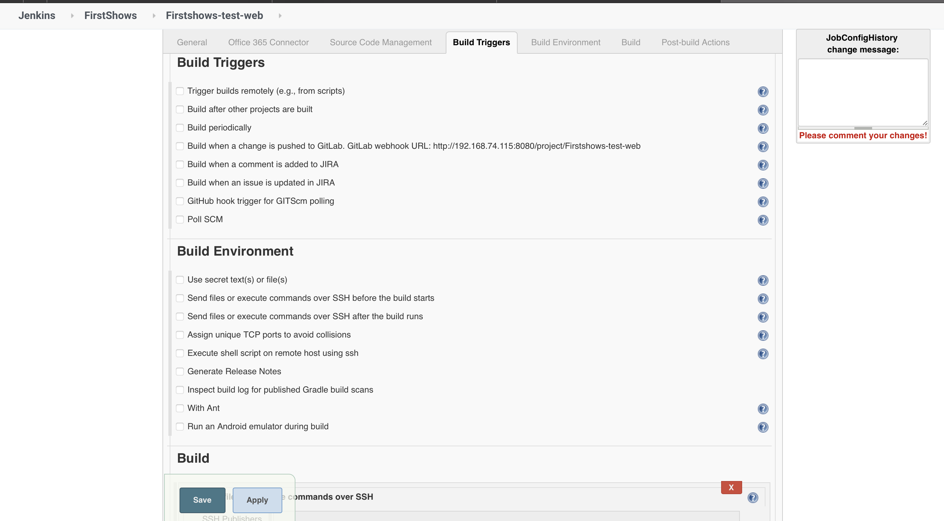**

**Build Environment**

**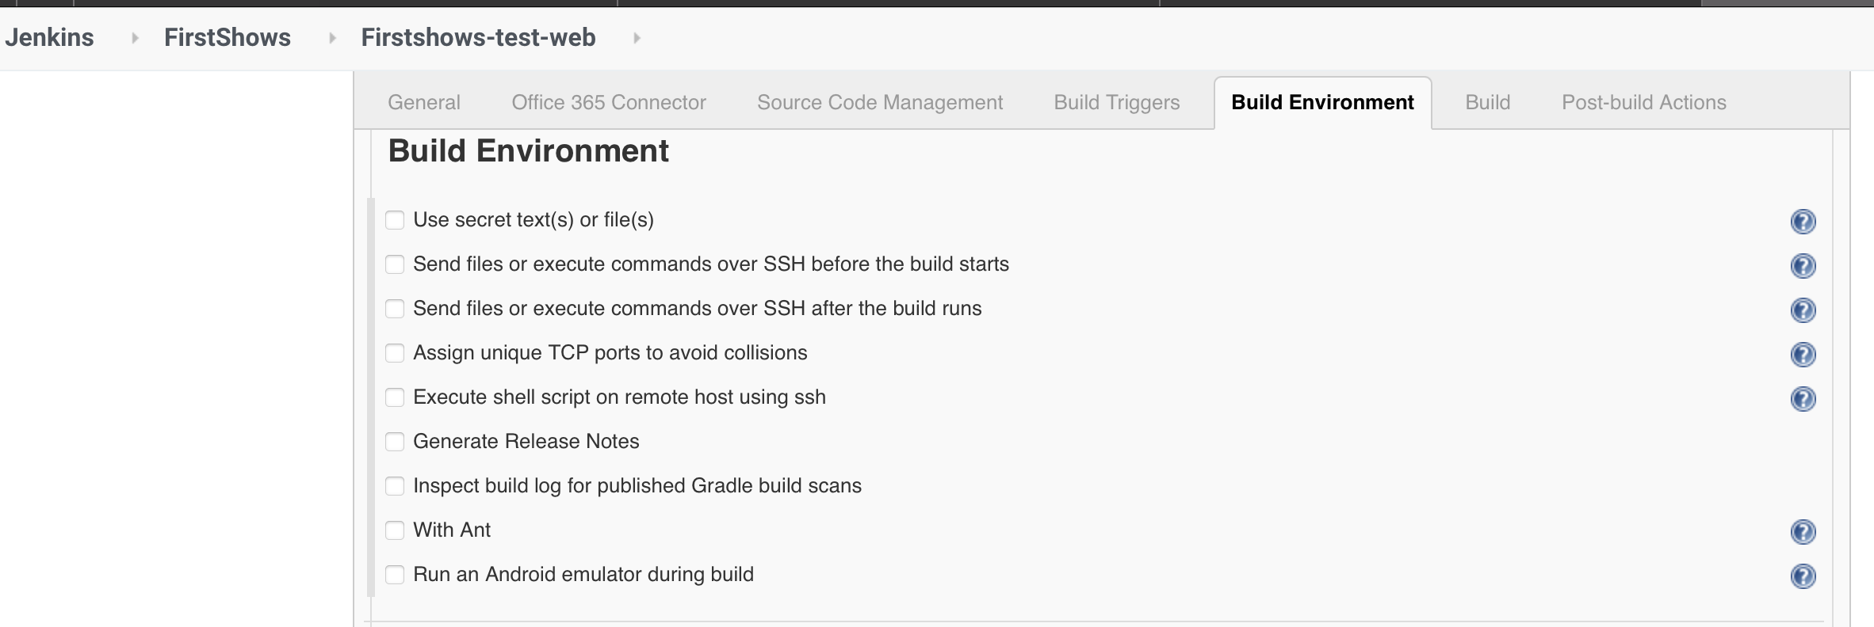**

**Build 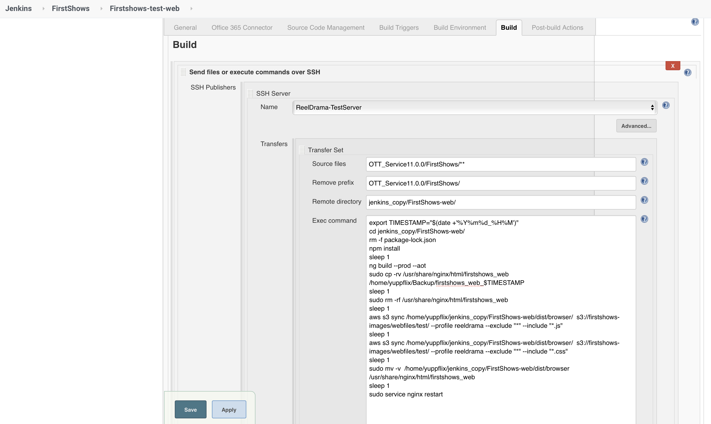**

export TIMESTAMP="$(date +'%Y%m%d\_%H%M')"

cd jenkins\_copy/FirstShows-web/

rm -f package-lock.json

npm install

sleep 1

ng build --prod --aot

sudo cp -rv /usr/share/nginx/html/firstshows\_web /home/yuppflix/Backup/firstshows\_web\_$TIMESTAMP

sleep 1

sudo rm -rf /usr/share/nginx/html/firstshows\_web

sleep 1

aws s3 sync /home/yuppflix/jenkins\_copy/FirstShows-web/dist/browser/ s3://firstshows-images/webfiles/test/ --profile reeldrama --exclude "\*" --include "\*.js"

sleep 1

aws s3 sync /home/yuppflix/jenkins\_copy/FirstShows-web/dist/browser/ s3://firstshows-images/webfiles/test/ --profile reeldrama --exclude "\*" --include "\*.css"

sleep 1

sudo mv -v /home/yuppflix/jenkins\_copy/FirstShows-web/dist/browser /usr/share/nginx/html/firstshows\_web

sleep 1

sudo service ngi

**App server Build configuration in Jenkins**

**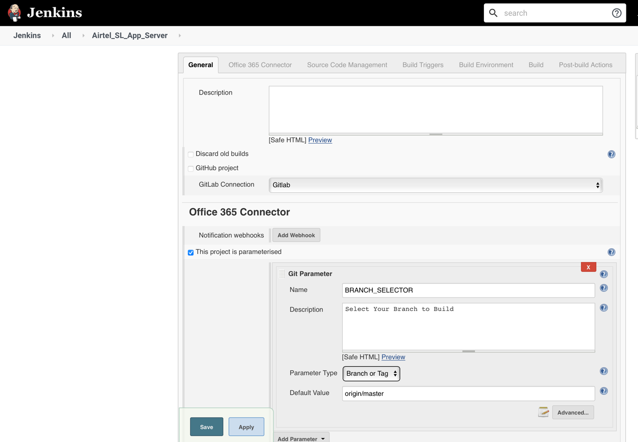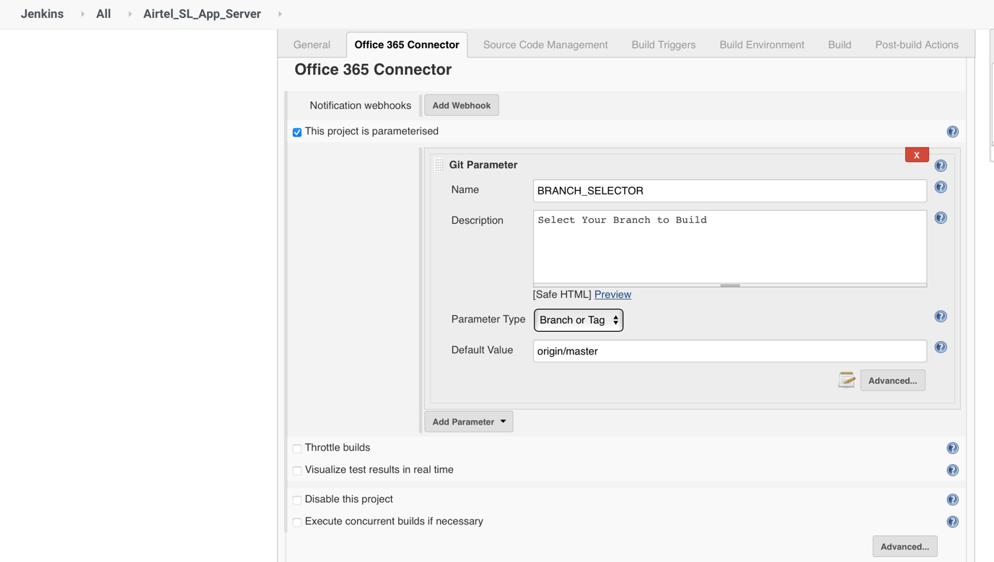**

**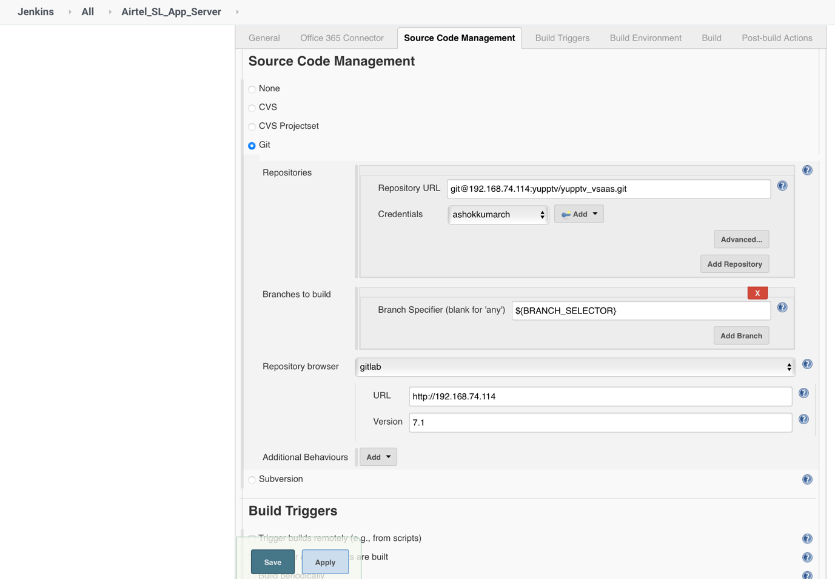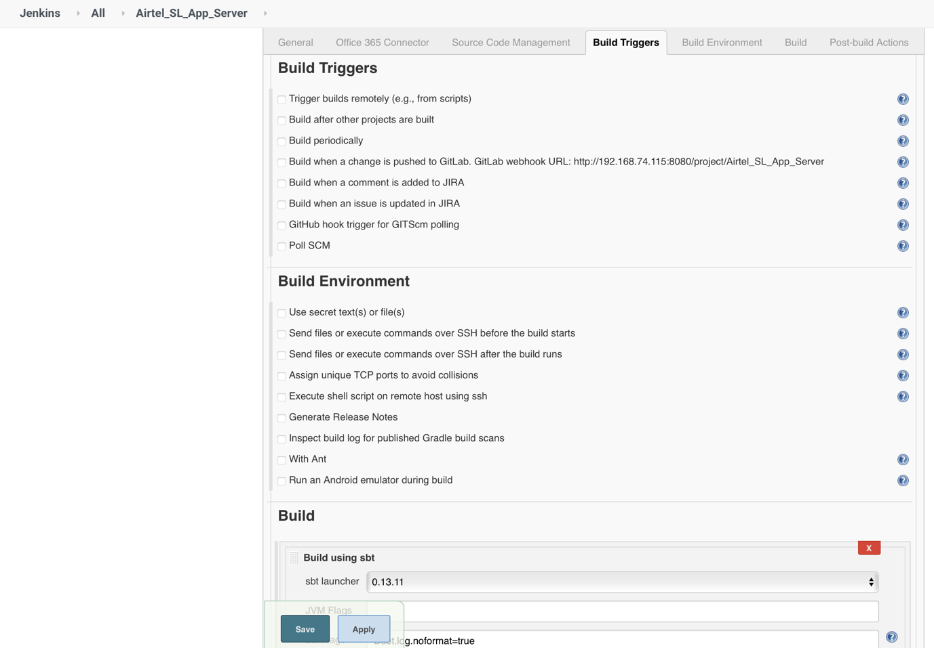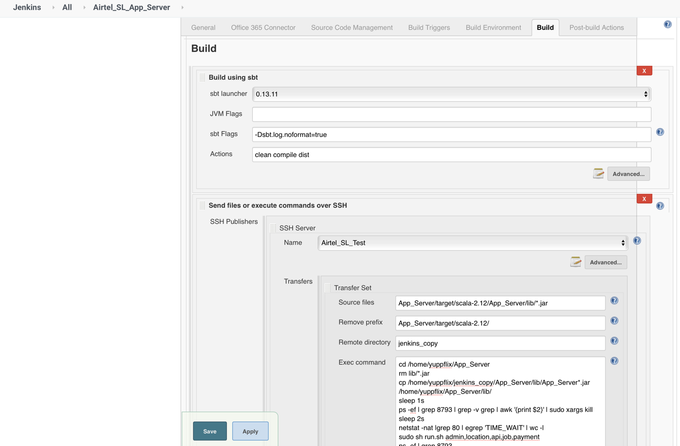**

cd /home/yuppflix/App\_Server

rm lib/\*.jar

cp /home/yuppflix/jenkins\_copy/App\_Server/lib/App\_Server\*.jar /home/yuppflix/App\_Server/lib/

sleep 1s

ps -ef | grep 8793 | grep -v grep | awk '{print $2}' | sudo xargs kill

sleep 2s

netstat -nat |grep 80 | egrep 'TIME\_WAIT' | wc -l

sudo sh run.sh admin,location,api,job,payment

ps -ef | grep 8793

sleep 2s

**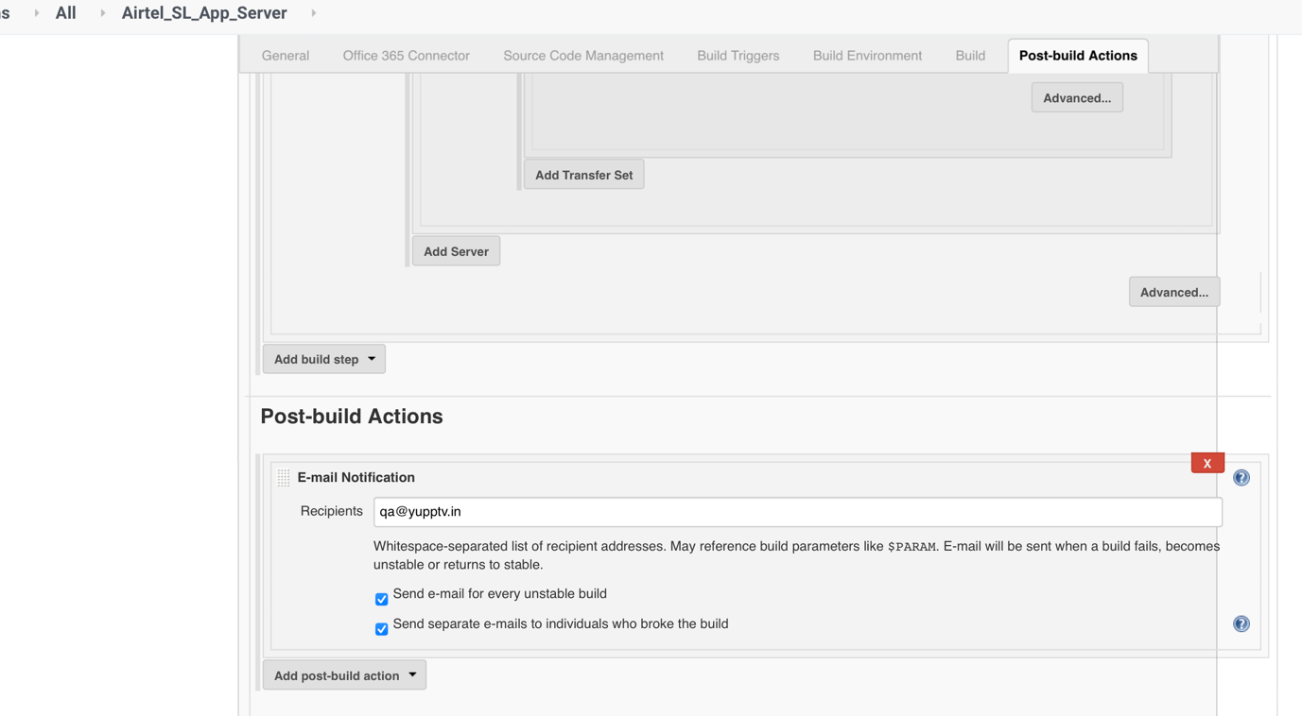**

**How is continuous integration(CI) achieved using Jenkins?**

**Answer:**

* All the developers commit their source code changes to the shared Git repository.
* Jenkins server checks the shared Git repository at specified intervals and detected changes are then taken into the build.
* The build results and test results are shared to the developers
* The built application is displayed on a test server like Selenium and automated tests are ran.
* The clean and tested build is deployed to the production server.

**Question: Jenkins Plugins**

**Answer:**

* Maven 2
* Gits
* Amazon EC2
* Role based Authorization strategy
* Cloudbees aws credentials
* Join
* Copy artifact
* Green Balls
* HTML Publisher

#### ****Question: What is Groovy?****

**Answer:** [Groovy](https://hackr.io/tutorials/learn-apache-groovy?ref=blog-post) from Apache is a language for Java platform. It is the native scripting language for Jenkins. Groovy-based plugins enhance Jenkins with great interfaces and build reports that are dynamic and consistent.

### **How can you clone a Git repository via Jenkins?**

If you want to clone a Git repository via Jenkins, you have to enter the e-mail and user name for your Jenkins system. Switch into your job directory and execute the "git config" command for that.

**Question: How does Jenkins authenticate users?**

**Answer:** There are 3 ways –

* The default way is to store user data and credentials in an internal database.
* Configure Jenkins to use the authentication mechanism defined by the application server on which it is deployed.
* Configure Jenkins to authenticate against LDAP server.

**Question: How can you use a third-party tool in Jenkins?**

**Answer:** Let us say we want to use the third-party tool Node.

* First make sure Node is installed.
* Though the Jenkins admin console, install the Jenkins plugin for node.
* Go to manage in the admin console and configure the settings on the Tools tab.
* You can add any configured nodeJS tool to your build job in a pipeline

For different third-party tools, the procedure may vary slightly, because of the difference in configuration settings.

### **What are the two components Jenkins is mainly integrated with?**

Jenkins mainly integrated with ?

Jenkins is integrated with these two components:

* Version Control system like GIT,SVN
* And build tools like Apache Maven.

**Question: What is the process of Jenkins?**

**Answer:**Jenkins automates the complete continuous deployment and delivery process through plugins. The process is as follows:

* Developers commit various source code changes to the Git repository.
* The Jenkins server keeps checking for repository changes and for every check-in, a build is done.
* Jenkins then deploys the built application to the test server (like Selenium). The test results are sent back as a feedback.
* Once all the tests are performed on the test server, the code is built on the production server.
* The feedback is again sent to the developer through the various levels (test server, Jenkins server, Git repo).

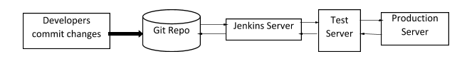

**Question: Describe the process to create a backup and copy files in Jenkins?**

**Answer:**To create a backup, you should periodically back up your JENKINS\_HOME directory.

This directory contains all the build jobs configurations, slave node configurations, and build history.

To create a backup, copy this directory, or you can also copy a job directory to replicate any job or rename the directory.

There are multiple method to back up the Jenkins configuration such as

Using ThinBackup or Backup plugin -go to manage Jenkins -click on available – select “thinbackup”-install without restart

Using the git repo

Manually backing up the Jenkins configuration or schedule a shell script using the corn

**Backup path - /apps/Jenkins\_backup**

**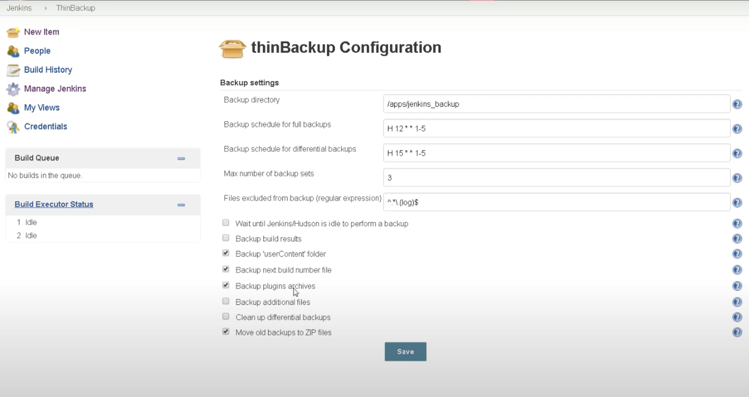**

**Question: Explain the process of creating the Multibranch Pipeline in Jenkins?**

**Answer:**The process is as follows:

* Open the Jenkins dashboard and create a new item by clicking on ‘new item’ from the top left menu.
* Enter your project name and from the options shown, select ‘Multibranch pipeline’ and click on OK.
* Then you should select the repository location, branch source (GitHub/Bitbucket), and add the credentials of the branch source.
* Save the project.
* Jenkins automatically creates new Multibranch Pipelines for repositories that have branches and pulls requests containing Jenkins files.
* To connect to the GitHub repo, we need the HookURL. Get this URL from the repository settings.
* Add this HookURL to the Webhooks section.
* Once the jobs are created, build is automatically triggered by Jenkins.

**Question: Explain the process to integrate Git with Jenkins?**

**Answer:**Here are the steps to integrate Git with Jenkins:

* Create a new Jenkins job and open the Jenkins dashboard.
* Enter the project name (in the item name) and select the job type. Click on OK.
* Enter the project information. Go to the ‘Source Code Management’ tab. If the Git plugin is already installed in Jenkins, you will see the option ‘Git’.
* If you cannot see it, then you should reinstall the plugins – GitHub plugin, GitHub Branch Source plugin, GitHub API plugin, Gitclient plugin etc.
* After installing the plugins, restart Jenkins to reflect the changes.
* To pull the code from GitHub, enter the repository URL. If you do not have Git installed in your machine, install it. To check if Git is installed, type Git in cmd (command prompt) and you should see various options like usage, version, help etc.

#### ****Question: What is Pipeline as a Code in Jenkins? Explain various types of Pipeline?****

**Answer:** Pipeline-as-a-code is a technique or set of features that help you maintain the CI/CD workflow logic in the source code repository without any additional configurations for each Jenkins branch. This is applicable for projects that have a file named as Jenkinsfile in the root folder of the repo (containing a pipeline script). The types of pipeline syntax are declarative and syntax.

* Declarative: These provide an easy way for creating pipelines and has a predefined hierarchy to create Jenkins pipelines. You can control all the aspects of the Pipeline.
* Scripted: It runs on the Jenkins master through a lightweight executor and uses few resources for translating the Pipeline into code (commands).

#### ****Question: What is a trigger? Give an example of how the repository is polled when a new commit is detected.****

**Answer:** Triggers define when and how pipelines should be executed.

When Jenkins is integrated with an SCM, for example, Git, the repository can be polled every time there is a commit.

* The Git plugin should be first installed and set up.
* After that, you can build a trigger that specifies when a new build should be started. For example, you can create a job that polls the repository and triggers a build when a change is committed.

**Jenkins Build Issues**

#### ****Question: If your project build is broken, what should you do?****

**Answer:** There are 2 ways to resolve a broken build –

* Open the console and double check if all the files are taken. If any changes are missing, place them correctly.
* Replicate the problem on your local set up to debug and fix the issue.

#### ****Question: Let us say, you have a pipeline. The first job was successful, but the second failed. What should you do next?****

**Answer:** You can restart the pipeline from the point where it failed by doing ‘restart from stage’.

#### ****Question: Have you run automated tests on Jenkins? How is it done?****

**Answer:** Yes. Automated tests can be run through tools like Selenium or maven. Developers can schedule the test runs. Jenkins displays the test results and sends a report to the developers

**Maven Tool Build tool**

This build tool is responsible of dependency and compiling multiple(more then 100 or thousand) files like bundle of codes compiling with dependency.

This build tools only java based application.

Artifact: package of or bundle of complied code available in ..war or jar format

.jdk it is java application is used for compiling java code

.jre: is used for to run the code

Def of Maven: Maven is a build automation tool used primarily for Java projects. Maven addresses two aspects of building software:

first, it describes how software is built, and

second, it describes its dependencies

pom.xml file is called it as definition file

compile can be triggered in the location where pom.xml file located

pom (project object model)

**What Maven does ?**

* Compilation of Source Code.
* Running Tests (unit tests and functional tests)
* Packaging the results into JAR’s,WAR’s,RPM’s,etc..
* Upload the packages to remote repo’s (Nexus,Artifactory)

### **What does the build tool?**

* Generates source code (if the auto-generated code is used)
* Generates documentation from source code
* Compiles source code
* Packages compiled code into a JAR or ZIP file
* Installs the packaged code in the local repository, server repository, or central repository

#### ****Question: What is Maven? What is the benefit of integrating maven with Jenkins?****

**Answer:** Maven is a build management tool. Using a simple pom.xml, one can configure all the dependencies needed to build, test and run the code. Maven manages the full lifecycle of a test project. Once integrated with Jenkins, the maven Webdriver will build the project and execute all tests efficiently.

#### ****Question: Explain the difference between Maven, Ant, and Jenkins?****

**Answer:**Jenkins is a CI tool, whereas Ant and Maven are build tools. Jenkins provides a trigger for the build to be executed. Maven and Ant can only perform build operations; however, Jenkins can run unit tests, deploy applications automatically.

Between Ant and Maven, Ant is just a tool and is procedural, whereas Maven is a complete declarative framework and has a lifecycle. Ant scripts cannot be reused, but Maven plugins can be reused. Ant is an old tool used by legacy systems. Most new applications use Maven.

**Maven Build Lifecycle**

Maven defines and follows conventions. Right from the project structure to building steps, Maven provides conventions to follow. If we follow those conventions, with minimal configuration we can easily get the build job done.

There are **three built-in build life cycle ‘clean’, ‘default’ and ‘site’**. A life cycle has multiple phases. For example, ‘default’ lifecycle has following phases (listed only the important phases),

* • compile — compiles the source code
* • test — executes unit test cases
* • package — bundles the compiled code (Ex: war / jar)
* • install — stores the built package in local Maven repository
* • deploy — store in remote repository for sharing

***mvn*** *<phase> {* Ex: ***mvn*** *install } js$ mvn install*

**clean** and **package** arguments are build phases while the **dependency:copy-dependencies**

mvn clean dependency:copy-dependencies package

**POM Example**

POM stands for **Project Object Model**. It is fundamental unit of work in Maven. It is an XML file that resides in the base directory of the project as pom.xml.And has all the configuration settings for the project build.

Generally we define the project dependencies (Ex: dependent jar files for a project), maven plugins to execute and project description /version etc.

Simplest pom.xml should have 4 important information.

* **1. modelVersion**-4.0.0 (*POM version for Maven 2 and is always required)*
* **2. groupId** —will identify your project uniquely across all projects, ex:ebs.obill.webs, com.companyname.project
* **3. artifactId**— is the name of the jar without version(keeping in mind that it should be jar-name friendly)
* **4. version** — if you distribute it then you can choose any typical version with numbers and dots (1.0, 1.1, 1.0.1, …)
* **5** .<project>  
   <modelVersion>4.0.0</modelVersion>  
   <groupId>com.intuit.jsapp</groupId>  
   <artifactId>js-app</artifactId>  
   <version>1</version>  
   </project>

## **Elements of maven pom.xml file**

For creating the simple pom.xml file, you need to have following elements:

|  |  |
| --- | --- |
| **Element** | **Description** |
| **project** | It is the root element of pom.xml file. |
| **modelVersion** | It is the sub element of project. It specifies the modelVersion. It should be set to 4.0.0. |
| **groupId** | It is the sub element of project. It specifies the id for the project group. |
| **artifactId** | It is the sub element of project. It specifies the id for the artifact (project). An artifact is something that is either produced or used by a project. Examples of artifacts produced by Maven for a project include: JARs, source and binary distributions, and WARs. |
| **version** | It is the sub element of project. It specifies the version of the artifact under given group. |

*File: pom.xml*

1. **<project** xmlns="http://maven.apache.org/POM/4.0.0"
2. xmlns:xsi="http://www.w3.org/2001/XMLSchema-instance"
3. xsi:schemaLocation="http://maven.apache.org/POM/4.0.0
4. http://maven.apache.org/xsd/maven-4.0.0.xsd"**>**
6. **<modelVersion>**4.0.0**</modelVersion>**
7. **<groupId>**com.javatpoint.application1**</groupId>**
8. **<artifactId>**my-app**</artifactId>**
9. **<version>**1**</version>**
11. **</project>**

## **4. Maven Dependencies**

There is an element available for declaring dependencies in project pom.xml This is used to define the dependencies that will be used by the project. Maven will look for these dependencies when executing in the local maven repository. If not found, then Maven will download those dependencies from the remote repository and store it in the local maven repository.

Example-

<dependencies>  
<dependency>  
<groupId>junit</groupId>  
<artifactId>junit</artifactId>  
<version>3.8.1</version>  
<scope>test</scope>  
</dependency>  
<dependency>  
<groupId>log4j</groupId>  
<artifactId>log4j</artifactId>  
<version>1.2.12</version>  
<scope>compile</scope>  
</dependency>  
</dependencies>

**5. Maven Puglins**

All the execution in Maven is done by plugins. A plugin is mapped to a phase and executed as part of it. A phase is mapped to multiple goals. Those goals are

executed by a plugin. We can directly invoke a specific goal while Maven execution. A plugin configuration can be modified using the plugin declaration.

An example for Maven plugin is ‘compiler’, it compiles the java source code. This compiler plugin has two goals compiler:compile and compiler:testCompile.

Using the configuration element, we can supply arguments to the plugin.

<build>  
 <finalName>springexcelexport</finalName>  
 <plugins>  
 <plugin>  
 <groupId>org.apache.maven.plugins</groupId>  
 <artifactId>maven-war-plugin</artifactId>  
 <version>2.2</version>  
 </plugin>  
 <plugin>  
 <groupId>org.apache.maven.plugins</groupId>  
 <artifactId>maven-surefire-plugin</artifactId>  
 <version>2.16</version>  
 <configuration>  
 <skipTests>true</skipTests>  
 </configuration>  
 </plugin>  
</build>

**Maven Project Structure**

Maven uses a convention for project folder structure. If we follow that, we need not describe in our configuration setting, what is located where. Maven knows from where to pick the source files, test cases etc. Following is a snap shot from a Maven project and it shows the project structure.

BANL13dd26e76:jaisriram agv$ tree  
.  
├── pom.xml  
└── src  
 ├── main  
 │ └── java  
 │ └── com  
 │ └── intuit  
 │ └── App.java  
 └── test  
 └── java  
 └── com  
 └── intuit  
 └── AppTest.java9 directories, 3 files

# **First Maven Project**

Let us create our first maven project. Hope you have setup Maven already. In Maven we have ‘Archetype’. It is nothing by a template for projects. Maven provides templates to start a project and using this we can quickly start a Maven project. Execute the following command in cmd prompt,

**agv$** mvn archetype:generate -DgroupId=com.js.demo.java -DartifactId=com.js.demo.java -DarchetypeArtifactId=maven-archetype-quickstart -DinteractiveMode=false

This will create a sample Maven project skeleton using we can start building the application.We will get a a pom.xml and let us use that to build the newly created Maven project. Go inside the newly created Maven project root and execute the command (this is where the pom.xml is available),

*mvn package*

Now this will execute all the Maven phases till the ‘package’ phase. That is, Maven will compile, verify and build the jar file and put it in target folder under the project.

**Maven Commands**

1. **mvn clean**

This command cleans the maven project by deleting the target directory. The command output relevant messages are shown below.

$ mvn clean ... [INFO] --- maven-clean-plugin:2.5:clean (default-clean) @ maven-example-jar --- [INFO] Deleting /Users/pankaj/Desktop/maven-examples/maven-example-jar/target ...

2. **mvn compiler:compile**

This command compiles the java source classes of the maven project.

$ mvn compiler:compile ... [INFO] --- maven-compiler-plugin:3.8.1:compile (default-cli) @ maven-example-jar --- [INFO] Changes detected - recompiling the module! [INFO] Compiling 1 source file to /Users/pankaj/Desktop/maven-examples/maven-example-jar/target/classes

... $

3. **mvn compiler:testCompile**

This command compiles the test classes of the maven project.

$ mvn compiler:testCompile ... [INFO] --- maven-compiler-plugin:3.8.1:testCompile (default-cli) @ maven-example-jar --- [INFO] Changes detected - recompiling the module! [INFO] Compiling 1 source file to /Users/pankaj/Desktop/maven-examples/maven-example-jar/target/test-classes

... $

4. **mvn package**

This command builds the maven project and packages them into a JAR, WAR,

etc.

$ mvn package

...

[INFO] --- maven-compiler-plugin:3.8.1:compile (default-compile) @ maven-example-jar ---

[INFO] Changes detected - recompiling the module!

[INFO] Compiling 1 source file to /Users/pankaj/Desktop/maven-examples/maven-example-jar/target/classes

...

[INFO] --- maven-compiler-plugin:3.8.1:testCompile (default-testCompile) @ maven-example-jar ---

[INFO] Changes detected - recompiling the module!

[INFO] Compiling 1 source file to /Users/pankaj/Desktop/maven-examples/maven-example-jar/target/test-classes

[INFO]

[INFO] --- maven-surefire-plugin:2.12.4:test (default-test) @ maven-example-jar ---

[INFO] Surefire report directory: /Users/pankaj/Desktop/maven-examples/maven-example-jar/target/surefire-reports

-------------------------------------------------------

T E S T S

-------------------------------------------------------

Running com.journaldev.maven.classes.AppTest

Tests run: 1, Failures: 0, Errors: 0, Skipped: 0, Time elapsed: 0.005 sec

Results :

Tests run: 1, Failures: 0, Errors: 0, Skipped: 0

[INFO]

[INFO] --- maven-jar-plugin:2.4:jar (default-jar) @ maven-example-jar ---

[INFO] Building jar: /Users/pankaj/Desktop/maven-examples/maven-example-jar/target/maven-example-jar-0.0.1-SNAPSHOT.jar

[INFO] ------------------------------------------------------------------------

[INFO] BUILD SUCCESS

...

### **5. mvn install**

This command builds the maven project and installs the project files (JAR, WAR, pom.xml, etc) to the local repository.

$ mvn install

...

[INFO] --- maven-resources-plugin:2.6:resources (default-resources) @ maven-example-jar ---

...

[INFO] --- maven-compiler-plugin:3.8.1:compile (default-compile) @ maven-example-jar ---

...

[INFO] --- maven-resources-plugin:2.6:testResources (default-testResources) @ maven-example-jar ---

...

[INFO] --- maven-compiler-plugin:3.8.1:testCompile (default-testCompile) @ maven-example-jar ---

...

[INFO] --- maven-surefire-plugin:2.12.4:test (default-test) @ maven-example-jar ---

...

[INFO] --- maven-jar-plugin:2.4:jar (default-jar) @ maven-example-jar ---

...

[INFO] --- maven-install-plugin:2.4:install (default-install) @ maven-example-jar ---

[INFO] Installing /Users/pankaj/Desktop/maven-examples/maven-example-jar/target/maven-example-jar-0.0.1-SNAPSHOT.jar to /Users/pankaj/.m2/repository/com/journaldev/maven/maven-example-jar/0.0.1-SNAPSHOT/maven-example-jar-0.0.1-SNAPSHOT.jar

[INFO] Installing /Users/pankaj/Desktop/maven-examples/maven-example-jar/pom.xml to /Users/pankaj/.m2/repository/com/journaldev/maven/maven-example-jar/0.0.1-SNAPSHOT/maven-example-jar-0.0.1-SNAPSHOT.pom

...

**GIT Tool Source code management (SCM)**

### **What is Git?**

[Git](https://www.simplilearn.com/tutorials/git-tutorial/what-is-git) is a version control system for tracking changes in computer files and is used to help coordinate work among several people on a project while tracking progress over time. In other words, it’s a tool that facilitates source code management in software development.

### **What’s the difference between Git and GitHub?**

**Git**

* **Git is** a version control system that lets you manage and keep track of your source code history.
* Git is to manage projects, or a set of them when changes are made over time.
* It helps to track progress over time and coordinate work among several people on a project

**Git Hub**

* **GitHub is** a cloud-based hosting service that lets you manage **Git** repositories
* IT is web-based graphical interface. GitHub helps every team member to work together on the project from anywhere, making collaboration easy.

### **What is a Git repository?**

[Git repository](https://www.simplilearn.com/git-tutorial-article) refers to a place where all the Git files are stored. These files can either be stored on the local repository or on the remote repository.

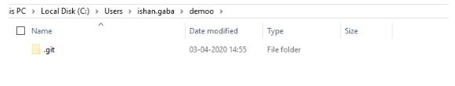

### **How can you initialize a repository in Git?**

If you want to initialize an empty repository to a directory in Git, you need to enter the **git init** command. After this command, a hidden **.git** folder will appear in the folder.

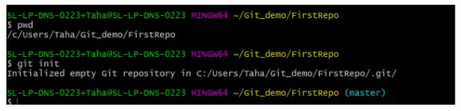

**git init**

This command turns a directory into an empty Git repository. This is the first step in creating a repository. After running git init, adding and committing files/directories is possible.

Usage:

# change directory to codebase

$ cd /file/path/to/code

# make directory a git repository

$ git init

In Practice:

# change directory to codebase

$ cd /Users/computer-name/Documents/website

# make directory a git repository

$ git init

Initialized empty Git repository in /Users/computer-name/Documents/website/.git/

**git add**

Adds files in the to the staging area for Git. Before a file is available to commit to a repository, the file needs to be added to the Git index (staging area). There are a few different ways to use git add, by adding entire directories, specific files, or all unstaged files.

$ git add <file or directory name>

In Practice:

# To add all files not staged:

$ git add .

# To stage a specific file:

$ git add index.html

# To stage an entire directory:

$ git add css

**git commit**

Record the changes made to the files to a local repository. For easy reference, each commit has a unique ID.

It’s best practice to include a message with each commit explaining the changes made in a commit. Adding a commit message helps to find a particular change or understanding the changes.

Usage:

# Adding a commit with message

$ git commit -m "Commit message in quotes"

In Practice:

$ git commit -m "My first commit message"

[SecretTesting 0254c3d] My first commit message

1 file changed, 0 insertions(+), 0 deletions(-)

create mode 100644 homepage/index.html

**git status**

This command returns the current state of the repository.

*git status* will return the current working branch. If a file is in the staging area, but not committed, it shows with *git status*. Or, if there are no changes it’ll return *nothing to commit, working directory clean.*

Usage:

$ git status

In Practice:

# Message when files have not been staged (git add)

$ git status

On branch SecretTesting

Untracked files:

(use "git add <file>..." to include in what will be committed)

homepage/index.html

# Message when files have been not been committed (git commit)

$ git status

On branch SecretTesting

Your branch is up-to-date with 'origin/SecretTesting'.

Changes to be committed:

(use "git reset HEAD <file>..." to unstage)

new file: homepage/index.html

# Message when all files have been staged and committed

$ git status

On branch SecretTesting

nothing to commit, working directory clean

**git config**

With Git, there are many configurations and settings possible. *git config* is how to assign these settings. Two important settings are user user.name and user.email. These values set what email address and name commits will be from on a local computer. With *git config*, a *--global* flag is used to write the settings to all repositories on a computer. Without a *--global* flag settings will only apply to the current repository that you are currently in.

There are many other variables available to edit in *git config*. From editing color outputs to changing the behavior of *git status*. Learn about *git config* settings in the official [Git documentation](https://git-scm.com/docs/git-config).

Usage:

$ git config <setting> <command>

In Practice:

# Running git config globally

$ git config --global user.email "my@emailaddress.com"

$ git config --global user.name "Brian Kerr"

# Running git config on the current repository settings

$ git config user.email "my@emailaddress.com"

$ git config user.name "Brian Kerr"

**git branch**

To determine what branch the local repository is on, add a new branch, or delete a branch.

Usage:

# Create a new branch

$ git branch <branch\_name>

# List all remote or local branches

$ git branch -a

# Delete a branch

$ git branch -d <branch\_name>

In Practice:

# Create a new branch

$ git branch new\_feature

# List branches

$ git branch -a

\* SecretTesting

new\_feature

remotes/origin/stable

remotes/origin/staging

remotes/origin/master -> origin/SecretTesting

# Delete a branch

$ git branch -d new\_feature

Deleted branch new\_feature (was 0254c3d).

**git checkout**

To start working in a different branch, use *git checkout* to switch branches.

Usage:

# Checkout an existing branch

$ git checkout <branch\_name>

# Checkout and create a new branch with that name

$ git checkout -b <new\_branch>

In Practice:

# Switching to branch 'new\_feature'

$ git checkout new\_feature

Switched to branch 'new\_feature'

# Creating and switching to branch 'staging'

$ git checkout -b staging

Switched to a new branch 'staging'

**git merge**

Integrate branches together. *git merge* combines the changes from one branch to another branch. For example, merge the changes made in a staging branch into the stable branch.

Usage:

# Merge changes into current branch

$ git merge <branch\_name>

In Practice:

# Merge changes into current branch

$ git merge new\_feature

Updating 0254c3d..4c0f37c

Fast-forward

homepage/index.html | 297 ++++++++++++++++++++++++++++++++++++++++++++++++++++++++

1 file changed, 297 insertions(+)

create mode 100644 homepage/index.html

Working with remote repositories

**git remote**

To connect a local repository with a remote repository. A remote repository can have a name set to avoid having to remember the URL of the repository.

Usage:

# Add remote repository

$ git remote <command> <remote\_name> <remote\_URL>

# List named remote repositories

$ git remote -v

In Practice:

# Adding a remote repository with the name of beanstalk

$ git remote add origin git@account\_name.git.beanstalkapp.com:/acccount\_name/repository\_name.git

# List named remote repositories

$ git remote -v

origin git@account\_name.git.beanstalkapp.com:/acccount\_name/repository\_name.git (fetch)

origin git@account\_name.git.beanstalkapp.com:/acccount\_name/repository\_name.git (push)

*Note: A remote repository can have any name. It’s common practice to name the remote repository ‘origin’.*

**git clone**

To create a local working copy of an existing remote repository, use *git clone* to copy and download the repository to a computer. Cloning is the equivalent of *git init* when working with a remote repository. Git will create a directory locally with all files and repository history.

Usage:

$ git clone <remote\_URL>

In Practice:

$ git clone git@account\_name.git.beanstalkapp.com:/acccount\_name/repository\_name.git

Cloning into 'repository\_name'...

remote: Counting objects: 5, done.

remote: Compressing objects: 100% (3/3), done.

remote: Total 5 (delta 0), reused 0 (delta 0)

Receiving objects: 100% (5/5), 3.08 KiB | 0 bytes/s, done.

Checking connectivity... done.

**git pull**

To get the latest version of a repository run *git pull*. This pulls the changes from the remote repository to the local computer.

Usage:

$ git pull <branch\_name> <remote\_URL/remote\_name>

In Practice:

# Pull from named remote

$ git pull origin staging

From account\_name.git.beanstalkapp.com:/account\_name/repository\_name

\* branch staging -> FETCH\_HEAD

\* [new branch] staging -> origin/staging

Already up-to-date.

# Pull from URL (not frequently used)

$ git pull git@account\_name.git.beanstalkapp.com:/acccount\_name/repository\_name.git staging

From account\_name.git.beanstalkapp.com:/account\_name/repository\_name

\* branch staging -> FETCH\_HEAD

\* [new branch] staging -> origin/staging

Already up-to-date.

**git push**

Sends local commits to the remote repository. *git push* requires two parameters: the remote repository and the branch that the push is for.

Usage:

$ git push <remote\_URL/remote\_name> <branch>

# Push all local branches to remote repository

$ git push —all

In Practice:

# Push a specific branch to a remote with named remote

$ git push origin staging

Counting objects: 5, done.

Delta compression using up to 4 threads.

Compressing objects: 100% (3/3), done.

Writing objects: 100% (5/5), 734 bytes | 0 bytes/s, done.

Total 5 (delta 2), reused 0 (delta 0)

To git@account\_name.git.beanstalkapp.com:/acccount\_name/repository\_name.git

ad189cb..0254c3d SecretTesting -> SecretTesting

# Push all local branches to remote repository

$ git push --all

Counting objects: 4, done.

Delta compression using up to 4 threads.

Compressing objects: 100% (4/4), done.

Writing objects: 100% (4/4), 373 bytes | 0 bytes/s, done.

Total 4 (delta 2), reused 0 (delta 0)

remote: Resolving deltas: 100% (2/2), completed with 2 local objects.

To git@account\_name.git.beanstalkapp.com:/acccount\_name/repository\_name.git

0d56917..948ac97 master -> master

ad189cb..0254c3d SecretTesting -> SecretTesting

Advanced Git Commands

**git stash (To revert back changes )**

To save changes made when they’re not in a state to commit them to a repository. This will store the work and give a clean working directory. For instance, when working on a new feature that’s not complete, but an urgent bug needs attention.

Usage:

# **Store current work with untracked files**

$ git stash -u

# **Bring stashed work back to the working directory**

$ git stash pop

In Practice:

# **Store current work**

$ git stash -u

Saved working directory and index state WIP on SecretTesting: 4c0f37c Adding new file to branch

HEAD is now at 4c0f37c Adding new file to branch

# **Bring stashed work back to the working directory**

$ git stash pop

On branch SecretTesting

Your branch and 'origin/SecretTesting' have diverged,

and have 1 and 1 different commit each, respectively.

(use "git pull" to merge the remote branch into yours)

Changes not staged for commit:

(use "git add <file>..." to update what will be committed)

(use "git checkout -- <file>..." to discard changes in working directory)

modified: index.html

no changes added to commit (use "git add" and/or "git commit -a")

Dropped refs/stash@{0} (3561897724c1f448ae001edf3ef57415778755ec)

**To add user in git**

Git config –global user.name “testuser”

**git log**

To show the chronological commit history for a repository. This helps give context and history for a repository. *git log* is available immediately on a recently cloned repository to see history.

Usage:

# **Show entire git log**

$ git log

# **Show git log with date pameters**

$ git log --<after/before/since/until>=<date>

# **Show git log based on commit author**

$ git log --<author>="Author Name"

In Practice:

# **Show entire git log**

$ **git log**

commit 4c0f37c711623d20fc60b9cbcf393d515945952f

Author: Brian Kerr <my@emailaddress.com>

Date: Tue Oct 25 17:46:11 2016 -0500

Updating the wording of the homepage footer

commit 0254c3da3add4ebe9d7e1f2e76f015a209e1ef67

Author: Ashley Harpp <my@emailaddress.com>

Date: Wed Oct 19 16:27:27 2016 -0500

My first commit message

# **Show git log with date pameters**

$ git log --before="Oct 20"

commit 0254c3da3add4ebe9d7e1f2e76f015a209e1ef67

Author: Ashley Harpp <my@emailaddress.com>

Date: Wed Oct 19 16:27:27 2016 -0500

My first commit message

# **Show git log based on commit author**

$ git log --author="Brian Kerr"

commit 4c0f37c711623d20fc60b9cbcf393d515945952f

Author: Brian Kerr <my@emailaddress.com>

Date: Tue Oct 25 17:46:11 2016 -0500

Updating the wording of the homepage footer

**git rm**

Remove files or directories from the working index (staging area). With *git rm*, there are two options to keep in mind: force and cached. Running the command with force deletes the file. The cached command removes the file from the working index. When removing an entire directory, a recursive command is necessary.

Usage:

# **To remove a file from the working index (cached):**

$ git rm --cached <file name>

# **To delete a file (force):**

$ git rm -f <file name>

# **To remove an entire directory from the working index (cached**):

$ git rm -r --cached <directory name>

# **To delete an entire directory (force):**

$ git rm -r -f <file name>

In Practice:

# **To remove a file from the working index:**

$ git rm --cached css/style.css

rm 'css/style.css'

# **To delete a file (force):**

$ git rm -f css/style.css

rm 'css/style.css'

# **To remove an entire directory from the working index (cached):**

$ git rm -r --cached css/

rm 'css/style.css'

rm 'css/style.min.css'

# **To delete an entire directory (force):**

$ git rm -r -f css/

rm 'css/style.css'

rm 'css/style.min.css'

**Git commands**

Git config – to add or config the user in git Git config –global user.name “testuser”

* Git add - Add one or more files to the staging area
* Git diff - View the changes made to the file
* Git init - Initialize an empty Git repository
* Git commit - Commit changes to head but not to the remote repository
* Git push - push the content in a local repository to a remote repository. After a local repository has been modified, a push is executed to share the modifications with remote team members.
* Git pull - Git pull is used to fetch and merge changes from the remote repository to the local repository. Git pull is a combination of two commands: git fetch; followed by git merge.
* **git-stash - Stash the changes in a dirty working directory away**
* **git stash** list [<log-options>]
* **git stash** show [<diff-options>] [<stash>]
* **git stash** drop [-q|--quiet] [<stash>]
* **git stash** ( pop | apply ) [--index] [-q|--quiet] [<stash>]
* **git stash** branch <branchname> [<stash>]
* **git stash** [push [-p|--patch] [-k|--[no-]keep-index] [-q|--quiet]
* [-u|--include-untracked] [-a|--all] [-m|--message <message>]
* [--pathspec-from-file=<file> [--pathspec-file-nul]]
* [--] [<pathspec>…​]]
* **git stash** clear
* **git stash** create [<message>]
* **git stash** store [-m|--message <message>] [-q|--quiet] <commit>

**What is a commit message (git commit -m “name” )**

The commit command is executed in a Git project to record the progress in the local repository. The commit command is executed only after the files to be committed have been added to the staging area using the git add command.

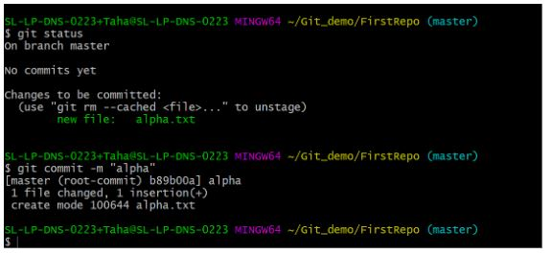

**Difference between git fetch and git pull.**

**Difference between git clone and git pull.**

**Difference between git clone and git fetch.**

### **git fetch**

* Git fetches only downloads new data from a remote repository.
* It does not integrate any of these new data into your working files.
* Can be done any time to update the remote-tracking branches

**Command - git fetch origin**

**git fetch –-all**

**git pull**

* Git pull updates the current HEAD branch with the latest changes from the remote server.
* Downloads new data and integrate it with the current working files.
* Tries to merge remote changes with your local ones.

**Command - git pull origin master**

**How do you resolve a merge conflict?**

To resolve a merge conflict in Git, follow these steps:

* The most simple way to resolve the conflicted file is to open it and make the required changes
* After editing the file, we can use the **git add a** command to stage the new merged content
* The final step is to create a new commit with the help of the **git commit** command
* Git will create a new merge commit to finalize the merge

### **What is a merge conflict in Git?**

### A [merge conflict](https://www.simplilearn.com/tutorials/devops-tutorial/devops-interview-questions) is an event that takes place when Git is unable to resolve differences in code between the two commits automatically.

Git is able to automatically merge the changes only if the commits are on different lines or branches.

## **How to Resolve Merge Conflicts in Git?**

There are a few steps that could reduce the steps needed to resolve merge conflicts in Git.

1. The easiest way to resolve a conflicted file is to open it and make any necessary changes
2. After editing the file, we can use the **git add a** command to stage the new merged content
3. The final step is to create a new commit with the help of the **git commit** command
4. Git will create a new merge commit to finalize the merge

Let us now look into the Git commands that may play a significant role in resolving conflicts.

## **Git Commands to Resolve Conflicts**

### **1. git log --merge**

The git log --merge command helps to produce the list of commits that are causing the conflict

### **2. git diff**

The git diff command helps to identify the differences between the states repositories or files

### **3. git checkout**

The git checkout command is used to undo the changes made to the file, or for changing branches

### **4. git reset --mixed**

The git reset --mixed command is used to undo changes to the working directory and staging area

### **5. git merge --abort**

The git merge --abort command helps in exiting the merge process and returning back to the state before the merging began

### **6. git reset**

The git reset command is used at the time of merge conflict to reset the conflicted files to their original state

### **What is Git stash?**

Let’s say you're a developer and you want to switch branches to work on something else. The issue is you don’t want to make commits in uncompleted work, so you just want to get back to this point later. The solution here is the Git stash.

Git stash takes your modified tracked files and saves it on a stack of unfinished changes that you can reapply at any time. To go back to the work you can use the stash pop.

### **What does the git reset --mixed and git merge --abort commands do?**

**git reset --mixed** is used to undo changes made in the working directory and staging area.

**git merge --abort** helps stop the merge process and return back to the state before the merging began.

### **If you recover a deleted branch, what work is restored?**

The files that were stashed and saved in the stash index can be recovered. The files that were untracked will be lost. That’s why it's a good idea to stage and commit your work or stash them.

### **What’s the difference between reverting and resetting?**

|  |  |
| --- | --- |
| **Reverting** | **Resetting** |
| The revert command in Git is used to create a new commit that undoes the changes made in the previous commit. When you use this command, a new history is added to the project; the existing history is not modified. | Git reset is a command that is used to undo the local changes that have been made to a Git repository. Git reset operates on the following: commit history, the staging index, and the working directory. |

### **How can you discover if a branch has already been merged or not?**

There are two commands to determine these two different things.

1. **git branch --merged** - Gives the list of branches that have been merged into the current branch.
2. **git branch --no-merged** - Gives the list of branches that have not been merged.

**How can you create a repository in Git?**

In Git, to create a repository, create a directory for the project if it does not exist, and then run command “git init”. By running this command .git directory will be created in the project directory, the directory does not need to be empty.

**What is the function of ‘git config’?**

The ‘git config’ command is a convenient way to set configuration options for your Git installation.  Behaviour of a repository, user info, preferences etc. can be defined through this command

**What is ‘head’ in git and how many heads can be created in a repository?**

A ‘head’ is simply a reference to a commit object. In every repository, there is a default head referred as “Master”.  A repository can contain any number of heads.

**What is the purpose of branching in GIT?**

The purpose of branching in GIT is that you can create your own branch and jump between those branches. It will allow you to go to your previous work keeping your recent work intact.

**What is the common branching pattern in GIT?**

The common way of creating branch in GIT is to maintain one as “Main“

branch and create another branch to implement new features. This pattern is particularly useful when there are multiple developers working on a single project.

**how can you bring a new feature in the main branch?**

To bring a new feature in the main branch, you can use a command “git merge” or “git pull command”.

**What is another option for merging in git?**

“Rebasing” is an alternative to merging in git.

## What is a webhook?

Webhooks are one of a few ways web applications can communicate with each other.

It allows you to send real-time data from one application to another whenever a given event occurs.

What a webhook does is notify you any time someone checks in, so you’d be able to run any processes that you had in your application once this event is triggered.

**Ansible Tool**

[**Write a playbook to install ‘git’  on all hosts if the file ‘/opt/collab’ exists on the system.**](https://www.zeolearn.com/interview-questions/ansible#collapse-beginner-1012)

---

- hosts: all

  vars:

      mario\_file: /opt/collab

      package\_list:

          - 'git'

  tasks:

      - name: Check for collab file

        stat:

            path: "{{ collab\_file }}"

        register: collab\_f

      - name: Install git if collab file exists

        become: "yes"

        package:

            name: "{{ item }}"

            state: present

        with\_items: "{{ package\_list }}"

        when: collab\_f.stat.exists

**To install different software on different severs both servers are ubuntu**

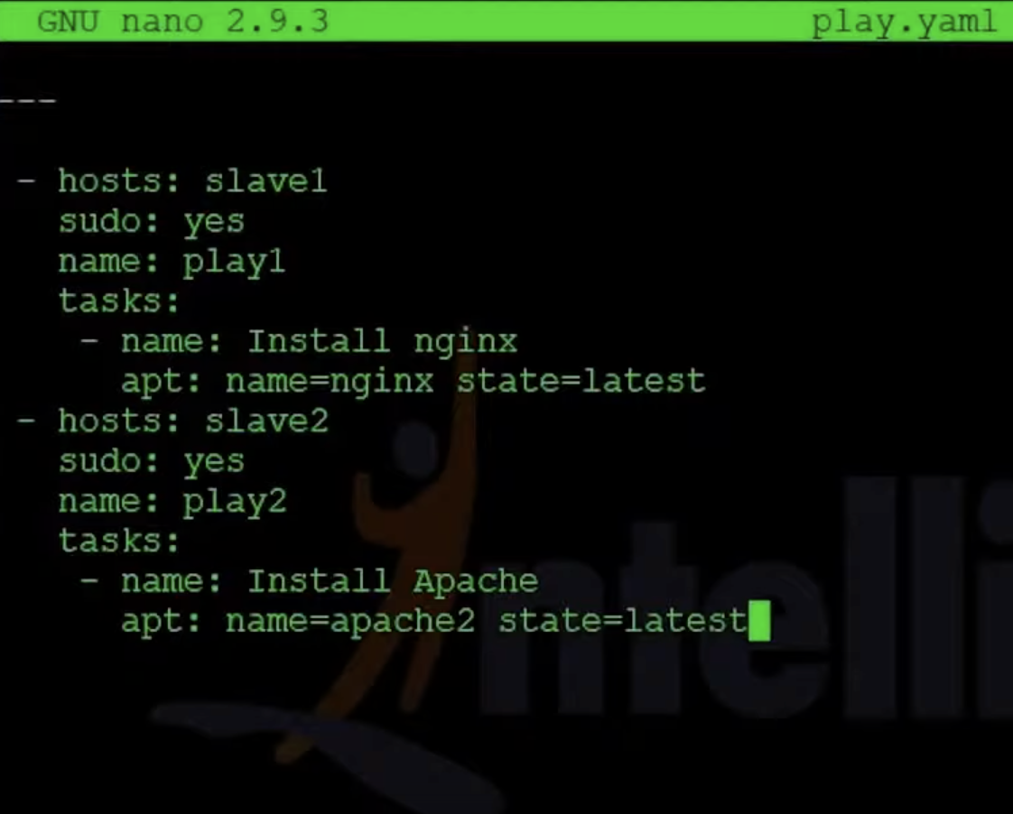

**Play book for Windows**

**Ansible installation on windows**

run .ps1 in windows

.\ConfigureRemotingForAnsible.ps1

(https://raw.githubusercontent.com/varmil/setup-winrm-for-windowsservercore/master/ConfigureRemotingForAnsible.ps1)

for winrm setup execute the below commands:

$url = "https://raw.githubusercontent.com/ansible/ansible/devel/examples/scripts/ConfigureRemotingForAnsible.ps1"

$file = "$env:temp\ConfigureRemotingForAnsible.ps1"

(New-Object -TypeName System.Net.WebClient).DownloadFile($url, $file)

powershell.exe -ExecutionPolicy ByPass -File $file

Get-ExecutionPolicy ( it most be in RemoteSigned )

if their is no value run the below command

Set-ExecutionPolicy "RemoteSigned"

to enable the winrm excute the below command

Enable-PSRemoting

After check once winrm https is allow or not

control pannel --> windows firewall --> Allow an apps through windows firewall

tick the box [Allow WinRM HTTPS]

pip install pywinrm ( linux machine )

vi /etc/ansible/hosts

[window]

192.168.\*\*\*.\*\*\*

[window:vars]

ansible\_user=@@@@@@@@@@@@@

ansible\_password=\*\*\*\*\*\*\*\*\*\*\*\*

ansible\_connection=winrm

ansible\_winrm\_server\_cert\_validation=ignore

$ ansible window -m win\_ping

output:

192.168.33.22 | SUCCESS => {

"changed": false,

"ping": "pong"

}

**copy play book**

**vi copy.yaml**

---

- hosts: windows

tasks:

- name: copy file local to windows machine

win\_copy:

src: /root/pra/cp.txt

dest: c:\Users\vagrant\Desktop\cp.txt

$ ansible-playbook copy.yaml

output:

PLAY [windows] \*\*\*\*\*\*\*\*\*\*\*\*\*\*\*\*\*\*\*\*\*\*\*\*\*\*\*\*\*\*\*\*\*\*\*\*\*\*\*\*\*\*\*\*\*\*\*\*\*\*\*\*\*\*\*\*\*\*\*\*\*\*\*\*\*\*\*\*\*\*\*\*\*\*\*\*\*\*\*\*\*\*\*\*\*\*\*\*\*\*\*\*\*\*\*\*\*\*\*\*\*\*\*\*\*\*\*\*\*\*\*\*\*\*\*\*\*\*\*\*\*\*\*\*\*\*\*\*\*\*\*\*\*\*\*\*\*\*\*\*\*\*\*\*\*\*\*

TASK [Gathering Facts] \*\*\*\*\*\*\*\*\*\*\*\*\*\*\*\*\*\*\*\*\*\*\*\*\*\*\*\*\*\*\*\*\*\*\*\*\*\*\*\*\*\*\*\*\*\*\*\*\*\*\*\*\*\*\*\*\*\*\*\*\*\*\*\*\*\*\*\*\*\*\*\*\*\*\*\*\*\*\*\*\*\*\*\*\*\*\*\*\*\*\*\*\*\*\*\*\*\*\*\*\*\*\*\*\*\*\*\*\*\*\*\*\*\*\*\*\*\*\*\*\*\*\*\*\*\*\*\*\*\*\*\*\*\*\*\*\*\*\*

ok: [192.168.33.22]

TASK [copy file local to windows machine] \*\*\*\*\*\*\*\*\*\*\*\*\*\*\*\*\*\*\*\*\*\*\*\*\*\*\*\*\*\*\*\*\*\*\*\*\*\*\*\*\*\*\*\*\*\*\*\*\*\*\*\*\*\*\*\*\*\*\*\*\*\*\*\*\*\*\*\*\*\*\*\*\*\*\*\*\*\*\*\*\*\*\*\*\*\*\*\*\*\*\*\*\*\*\*\*\*\*\*\*\*\*\*\*\*\*\*\*\*\*\*\*\*\*\*\*\*\*\*\*

changed: [192.168.33.22]

PLAY RECAP \*\*\*\*\*\*\*\*\*\*\*\*\*\*\*\*\*\*\*\*\*\*\*\*\*\*\*\*\*\*\*\*\*\*\*\*\*\*\*\*\*\*\*\*\*\*\*\*\*\*\*\*\*\*\*\*\*\*\*\*\*\*\*\*\*\*\*\*\*\*\*\*\*\*\*\*\*\*\*\*\*\*\*\*\*\*\*\*\*\*\*\*\*\*\*\*\*\*\*\*\*\*\*\*\*\*\*\*\*\*\*\*\*\*\*\*\*\*\*\*\*\*\*\*\*\*\*\*\*\*\*\*\*\*\*\*\*\*\*\*\*\*\*\*\*\*\*\*\*\*\*

192.168.33.22 : ok=2 changed=1 unreachable=0 failed=0

[**What are Ansible Modules?**](https://www.zeolearn.com/interview-questions/ansible#collapse-beginner-1018)

| **Module** | **Function** |
| --- | --- |
| copy | Copies files or folders from the local machine to the configured server |
| user | Creates, deletes or alters user accounts on the configured server |
| npm | Manages Node.JS packages |
| ping | Checks SSH connection to servers defined in inventory |
| setup | Collects various information about servers |
| cron | Manages crontab |

Command copy a file named "my\_app.zip" from the current directory to "/var/www/html" directory on the configured server.

**# ansible -m  copy -a “src=my\_app.zip  dest=/var/www/html”**

### **What’s an ad hoc command?**

Users initiate ad hoc commands to initiate actions on a host without using a playbook. Consider it a one-shot command.

What are Ansible roles?

**Ansible** role is a set of tasks to configure a host to serve a certain purpose like configuring a service. **Roles** are defined using YAML files with a predefined directory structure. A role directory structure contains directories: defaults, vars, tasks, files, templates, meta, handlers.

### **How to create roles**

### **What is Ansible Galaxy?**

Ansible Galaxy is a galaxy website where users can share roles and to a command-line tool for **installing, creating,** and **managing** roles.

### **Who you can copy file recursively onto a target host?**

The "copy" module has a recursive parameter. Therefore, if you want to perform more efficient for a large number of files, then the "synchronize" module is the best option for doing this task.

**DOCKER Tool**

 OS-level virtualization to deliver software in packages called containers. Containers are isolated from one another and bundle their own software, libraries and configuration files

Docker is a configuration management tool that is used to automate the deployment of software in lightweight containers. These containers help applications to work efficiently in different environments.

**Docker file is a simple text format**

FROM nginx:latest

MAINTAINER mavrick202@gmail.com

COPY index.html /usr/share/nginx/html/

COPY scorekeeper.js /usr/share/nginx/html/

COPY style.css /usr/share/nginx/html/

### **ENTRYPOINT**

ENTRYPOINT argument sets the concrete default application that is used every time a container is created using the image. For example, if you have installed a specific application inside an image and you will use this image to only run that application, you can state it with ENTRYPOINT and whenever a container is created from that image, your application will be the target.

If you couple ENTRYPOINT with CMD, you can remove “application” from CMD and just leave “arguments” which will be passed to the ENTRYPOINT

##### First, clone a repository

docker run --name repo alpine/git clone <https://github.com/docker/getting-started.git>

docker cp repo:/git/getting-started/ .

##### Now, build the image

**cd getting-started**

**docker build -t docker101tutorial .**

##### Run your first container

**docker run -d -p 80:80 --name docker-tutorial docker101tutorial**

##### Now save and share your image

**docker tag docker101tutorial rahulkasarla/docker101tutorial**

**docker push rahulkasarla/docker101tutorial**

#### ****Question: Briefly explain the Docker Container lifestyle.****

**Answer:**The lifecycle of a Docker Container is:

* Creation of the container
* Running the container
* Pausing the container
* Unpausing the container
* Starting the container
* Stopping the container
* Restarting the container
* Killing the container
* Destroying the container

#### ****Question: Name some important Docker commands****

**Answer:** Below is some important Docker commands:

* build: to build an image file for Docker
* create: for creation of a new container
* kill: to kill a container
* dockerd: for launching Docker daemon
* commit: for creating a new image from the container changes

#### ****Question: How to identify the status of a Docker Container?****

**Answer:**To identify the status of a Docker container, one should run the command

“**docker ps-a.**”

#### ****Question: Which networks all available by default in Docker?****

**Answer:**The default networks available in Docker are:

* **bridge**: Default network which the containers connect to if the network is not specified otherwise
* **none**: Connects to a container-specific network stack lacking a network interface
* **host**: Connects to the host’s network stack

#### ****Question: List the steps in a deploy process for Dockerized Apps stored In A Git Repo.****

**Answer:** While the deploy process changes with your production environment, a basic deploy process will have the following:

* Build an application through Docker Build located in the code directory
* Perform the test of an image
* Push the new image to registry docker
* Notify the remote application server to get hold of the image from the registry and run it
* Port swapping in HTTP proxy
* Stop the older container

#### ****Question: Explain various Docker Basic Commands?****

#### Answer: Some Docker commands are:

* docker push: pushes repository or image to a registry
* docker run: runs a command in a new container
* docker pull: pulls repository or image from a registry
* docker start: starts one or more containers
* docker stop: stops running containers
* docker search: searches for an image in a docker hub
* docker commit: commits new image

#### ****Question: Explain the various Docker Advanced Commands?****

**Answer:** Some important Docker commands are:

* docker -version: to know the installed docker version. Syntax, Docker --version
* docker ps: lists all the docker containers that are running along with the container details. Syntax: docker ps
* docker ps -a: lists all the containers, including those that are running, stopped, exited, along with the details. Syntax: docker ps -a
* docker exec: Access the container and run commands inside that container. Syntax: docker exec [options]
* docker build: builds an image from Dockerfile. Syntax: docker build [options] path|URL
* docker rm: Removes the container with the mentioned container id. Syntax: docker rm <container\_id>
* docker rmi: Removes the docker image with the mentioned image id. Syntax: docker rmi <image\_id>
* docker info: Gets detailed information about Docker installed on the system like the number of containers, images, running, paused, stopped, server version, volume, runtimes, kernel version, total memory etc. Syntax: docker info;
* docker cp: Copies a file from a docker container to a local system. Syntax: docker cp <source\_path> <dest\_path>
* docker history: displays the history of the docker image with the mentioned image name. Syntax: docker history <img\_name>

**8. What command should you run to see all running container in Docker?**

* $ docker ps

**9. Write the command to stop the docker container**

* $ sudo docker stop container name

**how to exit from docker container without stopping it**

CTRL+P+Q

**To enter into container** .

docker exec -it container name or id bash

**10. What is the command to run the image as a container?**

* $ sudo docker run -it alpine /bin/bash
* Sudo docker run -dit ubuntu

**13. Explain Docker Swarm?**

* Docker Swarm is native gathering for docker which helps you to a group of Docker hosts into a single and virtual docker host. It offers the standard docker application program interface.

**Write a Docker file to create and copy a directory and built it using python modules?**

FROM pyhton:2.7-slim

WORKDIR /app

COPY . /app

docker build –tag

**How to use JSON instead of YAML compose file?**

docker-compose -f docker-compose.json up

**27. What is the command you need to give to push the new image to Docker registry?**

docker push myorg/img

### A sample Docker Compose file

version: '3'

services:

# Tests the current internet connection speed

# once per hour and writes the results into an

# InfluxDB instance

speedtest:

image: robinmanuelthiel/speedtest:0.1.1

restart: always

depends\_on:

- influxdb

environment:

- LOOP=true

- LOOP\_DELAY=3600 # Once per hour

- DB\_SAVE=true

- DB\_HOST=http://influxdb:8086

- DB\_NAME=speedtest

- DB\_USERNAME=admin

- DB\_PASSWORD=<MY\_PASSWORD>

# Creates an InfluxDB instance to store the

# speed test results

influxdb:

image: influxdb

restart: always

volumes:

- influxdb:/var/lib/influxdb

ports:

- "8083:8083"

- "8086:8086"

environment:

- INFLUXDB\_ADMIN\_USER=admin

- INFLUXDB\_ADMIN\_PASSWORD=<MY\_PASSWORD>

- INFLUXDB\_DB=speedtest

# Displays the results in a Grafana dashborad

grafana:

image: grafana/grafana:latest

restart: always

depends\_on:

- influxdb

ports:

- 3000:3000

volumes:

- grafana:/var/lib/grafana

volumes:

grafana:

influxdb:

**Terraform**

**Define Terraform init?**

**Answer:**Terraform initializes the code using the command **terraform init**. This command is used to initialize the working directory containing Terraform configuration files. It is safe to run this command multiple times.

You can use the init command for:

1. Plugin Installation
2. Child Module Installation
3. Backend Initialization

**How does Terraform work?**

**Answer:**Terraform creates an implementation plan, define what it will do to attain the preferred state, and then executes it to construct the described infrastructure. As the configuration changes, Terraform is talented to decide what changed and generate incremental execution plans which can be practical.

---- I build infrastructure with terraform and for manage this infrastructure used ansible

Packer – Image building -AMI creation

I done some small task

Git-cicd-trigger

* Stage 1- AMI build with packer
* Stage 2- Infra Build (Terraform)
* Stage3- Build war/jar file for java
* Stage 4 Copy this war/jar file to the server and Deploy

Copy the terraform in **/usr/local/bin/ (**to work terraform from any location**)**

We can create multiple files in terraform

Terraform file

Main.tf

Outputs.tf

Test.tfvars

Variables.tf

**Name some major features of Terraform?**

**Answer:**Some of them are:

* Execution Plan
* Change Automation
* Resource Graph
* Infrastructure as code

**Explain the uses of Terraform CLI and list some basic CLI commands?**

* **terraform init**: Prepare your working directory for other commands
* **terraform validate**: Check whether the configuration is valid
* **terraform plan**: Show changes required by the current configuration
* **terraform apply**: Create or update infrastructure
* **terraform destroy**: Destroy previously-created infrastructure

**AWS amazon web services**

**AWS Service**

CloudFront

CloudWatch

Data Transfer

DynamoDB

Elastic Compute Cloud

Elastic Load Balancing

ElastiCache

Key Management Service

Lambda

Relational Database Service

Route 53

S3 Glacier Deep Archive

Savings Plans for AWS Compute usage

Simple Notification Service

Simple Storage Service

Support (Developer)

Virtual Private Cloud

# [**What is the diference between Network ACL and Route Tables in AWS?**](https://stackoverflow.com/questions/60211533/what-is-the-diference-between-network-acl-and-route-tables-in-aws)

A **Network Access Control List (Network ACL, or NACL)** is a firewall for a subnet.

All traffic entering or exiting a subnet is checked against the NACL rules to determine whether the traffic is allowed in/out of the subnet.

Traffic between instances within the same subnet do not pass through a NACL because the traffic is not exiting the subnet.

NACL rules are executed in a defined order. The first rule that matches the traffic will determine whether the traffic is allowed or denied.

Typically, NACLs are left at their default value of permitting all traffic. You should never have a need to modify a NACL unless you have a specific need, such as:

* Created a [DMZ](https://en.wikipedia.org/wiki/DMZ_(computing))
* Blocking specific types of traffic to all resources (eg blocking ICMP PING)
* Blocking specific IP addresses that are performing DDOS attacks

A **Route Table** is used to direct traffic in/out of a subnet. It contains a number of CIDRs (IP address ranges) and where to direct the appropriate traffic.

For example:

* Traffic for the Internet (0.0.0.0/0) is usually:
  + Sent to an Internet Gateway if the Route Table is associated with a public subnet
  + Sent to a NAT Gateway if the Route Table is associated with a private subnet
* Traffic for a Peered VPC is sent across a VPC Peering connection

It literally routes the traffic to the correct destination.

Want to know what makes a Public Subnet 'public'? It is the fact that the Route Table sends Internet-bound traffic to 0.0.0.0/0.

Traffic is sent to the smallest CIDR range that matches the destination. So, traffic matching 10.1.0.0/16 would be directed before traffic matching 0.0.0.0/0.

### **[1) Explain AWS S3 bucket?](https://www.onlineinterviewquestions.com/aws-s3-interview-questions/" \l "collapseUnfiled1)**

Amazon S3 (Simple Storage Service) is a simple web service interface that allows huge amount of data storage and retrival from anywhere from the internet.Its provides developers highly scalable, reliable, fast and low cost data storage infrastructure.

### **[2) What is the maximum size of S3 bucket?](https://www.onlineinterviewquestions.com/aws-s3-interview-questions/" \l "collapseUnfiled2)**

In S3 bucket you can store unlimited volume of data and number of objects. A single Amazon S3 objects can be a size of range 0 bytes to 5 terabytes. In single upload request You can put an object of around 5 GB but you must have to enable Multipart Upload capability.

### **[3) How to list objects of a S3 bucket?](https://www.onlineinterviewquestions.com/aws-s3-interview-questions/" \l "collapseUnfiled3)**

use aws s3 ls --recursive command on aws CLI to list all files or objects under the specified directory or prefix

### **[4) Explain process of mounting s3 to ec2 instance?](https://www.onlineinterviewquestions.com/aws-s3-interview-questions/" \l "collapseUnfiled4)**

## **Follow below steps to mount s3 to ec2 instance**

#### 1. Update the system

apt-get update

#### 2. Install the dependencies

sudo apt-get install automake autotools-dev fuse g++ git libcurl4-gnutls-dev libfuse-dev libssl-dev libxml2-dev make pkg-config

#### 3. Clone s3fs source code from git

git clone https://github.com/s3fs-fuse/s3fs-fuse.git

#### 4. Run below commands to change source code directory, compile and install the code.

cd s3fs-fuse

./autogen.sh

./configure --prefix=/usr --with-openssl

make

sudo make install

#### 5. Run s3fs command to check where command is placed

which s3fs

#### 6. Get your access key and secret key ready.

#### 7. Create a new file in /etc with the name passwd-s3fs and paste your access key and secret key.

touch /etc/passwd-s3fs

vim /etc/passwd-s3fs

Your\_accesskey:Your\_secretkey

#### 8. Change the permission of the file

sudo chmod 640 /etc/passwd-s3fs

#### 9. Now create a directory or provide the path of an existing directory and mount S3bucket in it.

mkdir /mys3bucket

s3fs your\_bucketname -o use\_cache=/tmp -o allow\_other -o uid=1001 -o mp\_umask=002 -o multireq\_max=5 /mys3bucket

### **[5) How to install aws s3 cli?](https://www.onlineinterviewquestions.com/aws-s3-interview-questions/" \l "collapseUnfiled5)**

Prerequisite to install AWS CLI.

* Python2 version 2.6.5+ or Python3 version 3.3+
* Windows, Linux, macOS,or Unix

After that, if you are using Unix or Linux system run below command to install AWS CLI

pip install awscli --upgrade --user

For window and other OS please read: <https://docs.aws.amazon.com/cli/latest/userguide/installing.html>

**Download Free :**[AWS S3 interview questions PDF](https://www.onlineinterviewquestions.com/pdfs/aws-s3-interview-questions.pdf)

### **[6) How to clear AWS S3 cache?](https://www.onlineinterviewquestions.com/aws-s3-interview-questions/" \l "collapseUnfiled6)**

You can use invalidations to clear AWS S3 cache. To create invalidations login to AWS Console and go to **Distribution Settings > Invalidations > Create Invalidation**. Once invalidation is created just type path of file or a wildcard to purge the cache.

### **[7) How to delete a AWS s3 bucket?](https://www.onlineinterviewquestions.com/aws-s3-interview-questions/" \l "collapseUnfiled7)**

Here are steps to delete an S3 bucket:-

* **Step1:** Login to AWS Management Console.
* **Step2:** Select S3 from services.
* **Step3:** Check the bucket you want to delete.
* **Step4:** Click on the delete button. As confirmation Aws ask you to type the bucket name to delete.
* **Step5**: Type bucket name and click on the Confirm button.

### **[8) How to get AWS S3 access key?](https://www.onlineinterviewquestions.com/aws-s3-interview-questions/" \l "collapseUnfiled8)**

### **[9) What are options available for protecting data at rest in Amazon S3?](https://www.onlineinterviewquestions.com/aws-s3-interview-questions/" \l "collapseUnfiled9)**

### **[10) Explain S3 Versioning? What are benefits of using versioning in S3.](https://www.onlineinterviewquestions.com/aws-s3-interview-questions/" \l "collapseUnfiled10)**

**Versioning** allows us to keep multiple variants of an object in a bucket. Versioning helps us to restore an object to a previous or specific version of an object. You can take advantage of versioning to recover a deleted or mistakenly overwritten object.

### **[11) How to Configure Versioning on a Bucket?](https://www.onlineinterviewquestions.com/aws-s3-interview-questions/" \l "collapseUnfiled11)**

Versioning helps you to keep multiple versions of an object in one bucket. Here are simple steps to enable versioning on an S3 bucket.

* **Step1:** Login to your AWS console.
* **Step2:** From services choose S3.
* **Step3:** Select a bucket for which you want to enable versioning.
* **Step4:** Click on the properties tab.
* **Step5:** Choose versioning from properties.
* **Step6:** Choose to enable versioning and click on the Ok button.

### **[12) How to enable Multipart Upload capability in Amazon S3.](https://www.onlineinterviewquestions.com/aws-s3-interview-questions/" \l "collapseUnfiled12)**

### **[13) What is AWS s3fs.](https://www.onlineinterviewquestions.com/aws-s3-interview-questions/" \l "collapseUnfiled13)**

It is a FUSE filesystem. Amazon web services simple storage service supports it. It can be operated with two different methods

**1.Command method-**

In this type of mode, s3fs is eligible for managing Amazon s3 buckets in several efficient methods.

**2. Mount method-**

It is used to mount the Amazon s3 bucket as a local file system.

## **Types of AWS Load balancer**

**Application load balancer**

**Network load balancer**

**Classic load balancer**

## **Application Load Balancer**

An Application Load Balancer makes routing decisions at the application layer (HTTP/HTTPS), supports path-based routing, and can route requests to one or more ports on each container instance in your cluster. Application Load Balancers support dynamic host port mapping. For example, if your task's container definition specifies port 80 for an NGINX container port, and port 0 for the host port, then the host port is dynamically chosen from the ephemeral port range of the container instance (such as 32768 to 61000 on the latest Amazon ECS-optimized AMI). When the task is launched, the NGINX container is registered with the Application Load Balancer as an instance ID and port combination, and traffic is distributed to the instance ID and port corresponding to that container. This dynamic mapping allows you to have multiple tasks from a single service on the same container instance. For more information, see the [User Guide for Application Load Balancers](https://docs.aws.amazon.com/elasticloadbalancing/latest/application/).

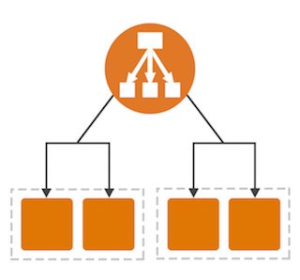

## **Network Load Balancer**

A Network Load Balancer makes routing decisions at the transport layer (TCP/SSL). It can handle millions of requests per second. After the load balancer receives a connection, it selects a target from the target group for the default rule using a flow hash routing algorithm. It attempts to open a TCP connection to the selected target on the port specified in the listener configuration. It forwards the request without modifying the headers. Network Load Balancers support dynamic host port mapping. For example, if your task's container definition specifies port 80 for an NGINX container port, and port 0 for the host port, then the host port is dynamically chosen from the ephemeral port range of the container instance (such as 32768 to 61000 on the latest Amazon ECS-optimized AMI). When the task is launched, the NGINX container is registered with the Network Load Balancer as an instance ID and port combination, and traffic is distributed to the instance ID and port corresponding to that container. This dynamic mapping allows you to have multiple tasks from a single service on the same container instance. For more information, see the [User Guide for Network Load Balancers](https://docs.aws.amazon.com/elasticloadbalancing/latest/network/).



## **Classic Load Balancer**

A Classic Load Balancer makes routing decisions at either the transport layer (TCP/SSL) or the application layer (HTTP/HTTPS). Classic Load Balancers currently require a fixed relationship between the load balancer port and the container instance port. For example, it is possible to map the load balancer port 80 to the container instance port 3030 and the load balancer port 4040 to the container instance port 4040. However, it is not possible to map the load balancer port 80 to port 3030 on one container instance and port 4040 on another container instance. This static mapping requires that your cluster has at least as many container instances as the desired count of a single service that uses a Classic Load Balancer. For more information, see the [User Guide for Classic Load Balancers](https://docs.aws.amazon.com/elasticloadbalancing/latest/classic/).

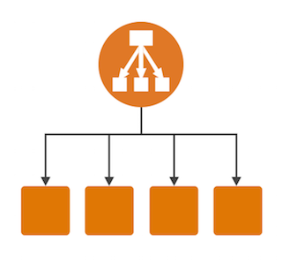

### **What is auto-scaling?**

[Auto-scaling](https://www.simplilearn.com/tutorials/aws-tutorial/aws-auto-scaling) is a function that allows you to provision and launch new instances whenever there is a demand. It allows you to automatically increase or decrease resource capacity in relation to the demand.

**CloudFront**-

* Is a fast content delivery network (CDN) service that securely delivers data, videos, applications, and APIs to customers globally with low latency, high transfer speeds, all within a developer-friendly environment.
* Offers the most advanced security capabilities, including field level encryption and HTTPS support

**CloudWatch-**

* CloudWatch is a monitoring and observability service
* CloudWatch provides you with data and actionable insights to monitor your applications, respond to system-wide performance changes, optimize resource utilization, and get a unified view of operational health.
* CloudWatch collects monitoring and operational data in the form of logs, metrics, and events, providing you with a unified view of AWS resources, applications, and services that run on AWS and on-premises servers.
* You can use CloudWatch to detect anomalous behavior in your environments, set alarms, visualize logs and metrics side by side, take automated actions, troubleshoot issues, and discover insights to keep your applications running smoothly.

**What is DNS ?**

DNS, or the Domain Name System, translates human readable domain names to machine readable IP addresses

For example - [www.tcs.com](http://www.tcs.com) to 23.58.220

**Types of DNS service**

**ADNS and RDNS**

**ADNS (**Authoritative DNS)

* An authoritative DNS service provides an update mechanism that developers use to manage their public DNS names

**Route 53**

* **Route 53** to perform **three main functions** in any combination:
* domain registration, DNS **routing**, and health checking.
* Your website needs a name, such as www.example.com. **Route 53** lets you register a name for your website or web application, known as a domain name.
* You can create records that have a type of addresses.

IPv4 =A

IPv6= AAAA, addresses.

**S3**

* Simple Storage Service
* a simple web service interface that allows huge amount of data storage and retrieval from anywhere from the internet
* Its provides developers highly scalable, reliable, fast and low cost data storage infrastructure.

**Maximum size of S3**

* you can store unlimited volume of data .
* size of range 0 bytes to 5 terabytes
* You can put an object of around 5 GB but you must have to enable Multipart Upload capability.

### **How do you upgrade or downgrade a system with near-zero downtime?**

You can upgrade or downgrade a system with near-zero downtime using the following steps of migration:

* Open EC2 console
* Choose Operating System AMI
* Launch an instance with the new instance type
* Install all the updates
* Install applications
* Test the instance to see if it’s working
* If working, deploy the new instance and replace the older instance
* Once it’s deployed, you can upgrade or downgrade the system with near-zero downtime.

**AZURE Devops**

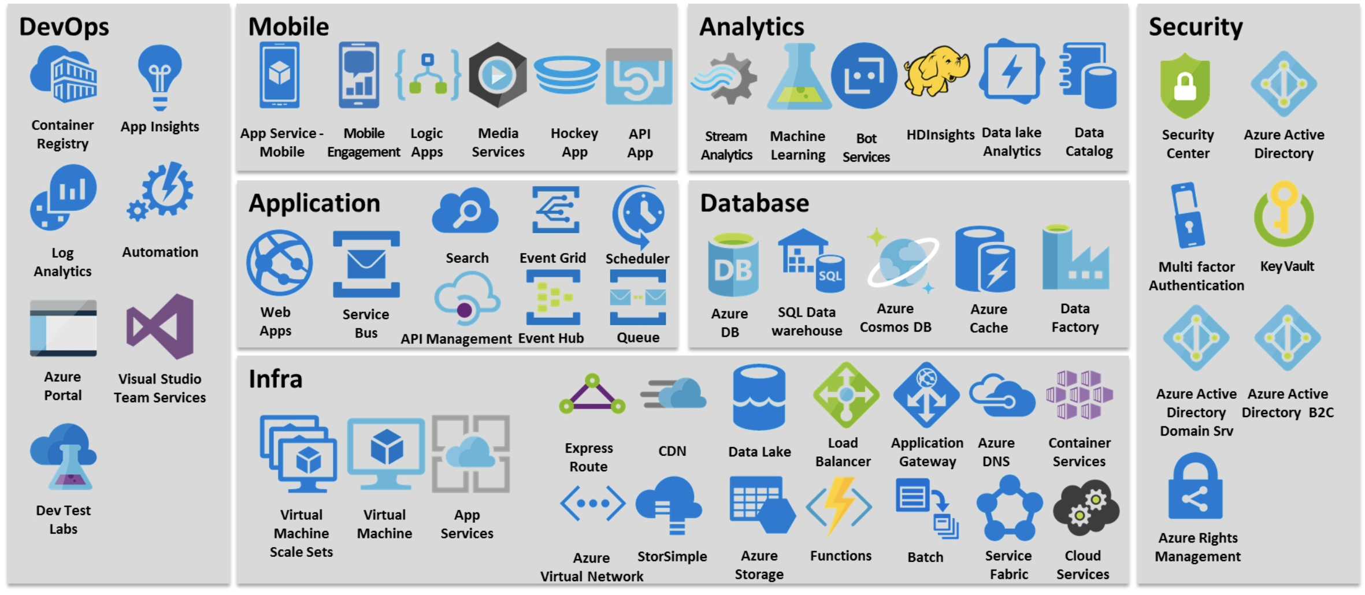

**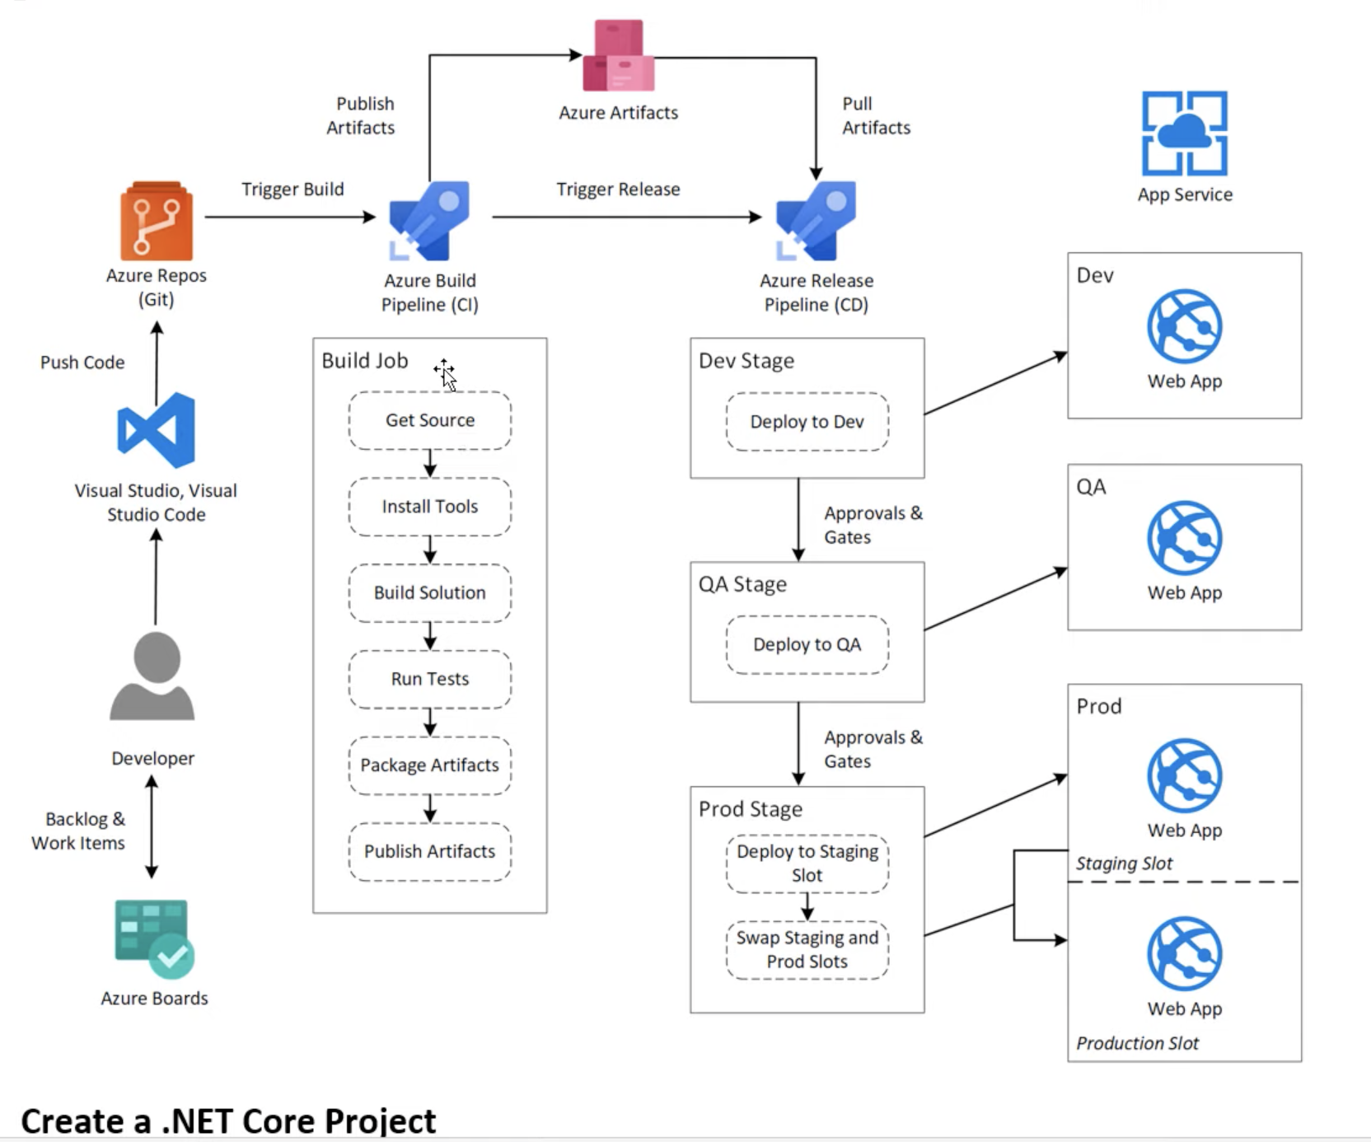**

**Create new organization**

Under this organization we will have multiple propjets

Create a project to get started

**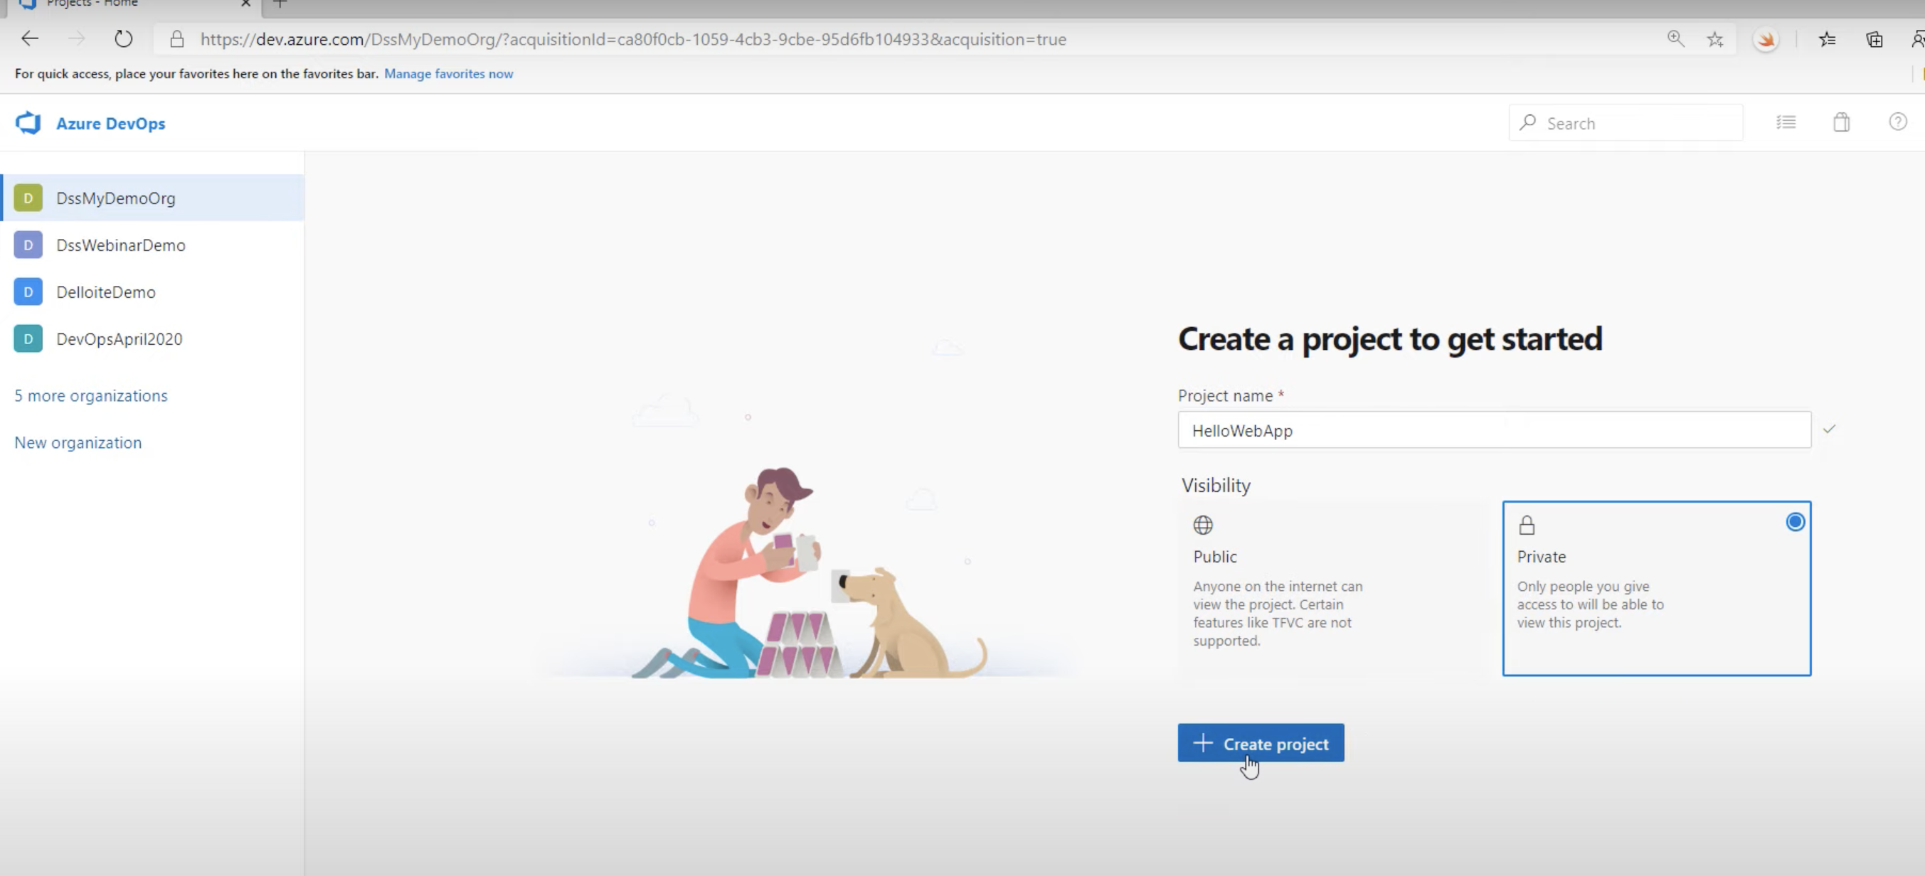**

**And** make it private (not public)

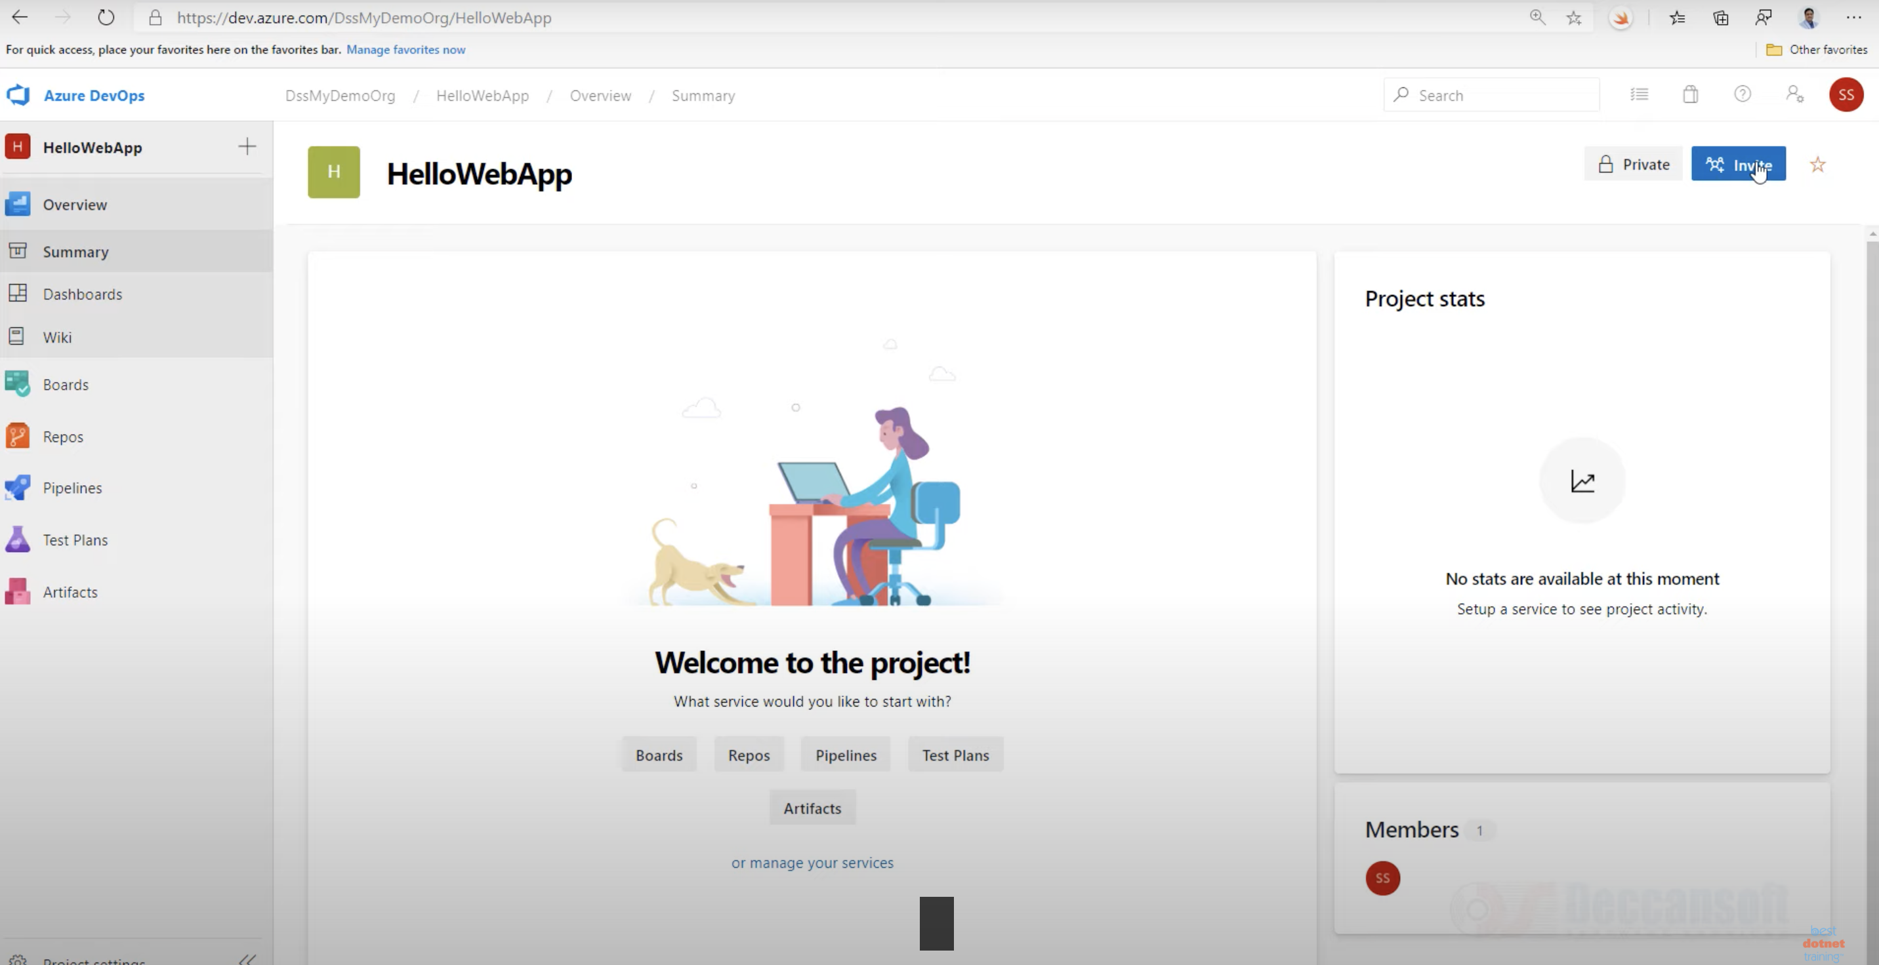

**LINUX**

**What is dollar $1 and $0 ?**

**$1** is the first command-line argument passed to the shell script. Also, know as Positional parameters. For example, $0, $1, $3, $4 and so on. If you run ./script.sh filename1 dir1, then:

* $0 is the name of the script itself (script.sh)
* $1 is the first argument (filename1)
* $2 is the second argument (dir1)
* $9 is the ninth argument
* ${10} is the tenth argument and must be enclosed in brackets after $9.
* ${11} is the eleventh argument.

**$1 and positional parameters example**

**What is a swap space?**

Swap space is a certain amount of space used by Linux to temporarily hold some programs that are running concurrently. This happens when RAM does not have enough memory to hold all programs that are executing.

**What are the basic components of Linux?**

Just like any other typical operating system, Linux has all of these components: kernel, shells and GUIs, system utilities, and an application program. What makes Linux advantageous over other operating system is that every aspect comes with additional features and all codes for these are downloadable for free.

**How can you find out how much memory Linux is using?**

From a command shell, use the "concatenate" command: cat /proc/meminfo for memory usage information. You should see a line starting something like Mem: 64655360, etc. This is the total memory Linux thinks it has available to use.

You can also use commands

free - m

vmstat

top

htop

to find current memory usage

**How do you change permissions under Linux?**

using the chmod

u (user), g (group), o (others), a (all), r (read), w (write) and x (execute)

example, the command chmod go+rw FILE1.TXT grants read and write access to the file FILE1.TXT, which is assigned to groups and others.

**In Linux, what names are assigned to the different serial ports?**

Serial ports are identified as /dev/ttyS0 to /dev/ttyS7. These are the equivalent names of COM1 to COM8 in Windows.

**How do you access partitions under Linux?**

Linux assigns numbers at the end of the drive identifier. For example, if the first IDE hard drive had three primary partitions, they would be named/numbered, /dev/hda1, /dev/hda2 and /dev/hda3.

**To print /to view ssh public key**

cat ~/.ssh/id\_rsa.pub

**To generate ssh key**

ssh-keygen

**To add key in remote server**

sudo vi .ssh/authorized\_keys

**To check running ports**

netstat -tulpn

**To check particular services port**

sudo netstat -tulpn | grep nginx

**nginx configurations**

/etc/nginx/sites-enabled

**Gitlab configurations**

Sudo nano /opt/gitlab/embedded/service/gitlab-rails/config/gitlab.yml

sudo gitlab-ctl restart

sudo nano /etc/gitlab/gitlab.rb

sudo gitlab-ctl reconfigure

**To find file in linux**

sudo find / -name Jenkins.log

tail /var/log/jenkins/jenkins.log

watch -n1 tail /var/log/jenkins/jenkins.log

Daaily activities

Checking monitoring tool notification and sns (Amazon CloudWatch Alarm )

Checking email’s

Checking jir tickets

And working on emails and jira tickets

Ticks and emails like

Giving access to user in git repo of the project

And giving access to the test servers with sshkey

Monitoring tool notification’s like

disk utilization , cpu utilization, memory utilization

in disk removing unwanted logs , or converting to file or copying to s3 its depends on impotency of data

when cpu utilization – stopping unwanted services, with sudo run.sh , it will stop and start services

Checking Jenkins jobs and build’s if there are any fails then trouble shooting analysing and providing to fix issues

When any deployments comes Integrating with QA team. And dev team for collaboration and enhance a daily integration

Working on automation on a daily basis

Making documentation on daily bases like server information daily configuration or modify the infra

Take Backup table in Posrgres:

-t --- Backup table in Posrgres

Example: pg\_dump -h frndlytv-db.cdv6absf6ksw.us-east-1.rds.amazonaws.com -p 5244 -U rivuletuser -d rivulet -t frndlytv.order\_refund\_detail > frndlytv.order\_refund\_detail\_29082019

redis-cli -h yupptv-dot-com-redis.ubc156.0001.use1.cache.amazonaws.com -p 6262

[yuppflix@ip-172-31-31-59 App\_Server]$ cat run.sh

#!/bin/sh

if [ ! -z "$1" ]

then

sed -i -e 's/Mode = .\*/Mode = \"'$1'\"/g' conf/app\_server.conf

else sed -i -e 's/Mode = .\*/Mode = \"admin,location,api,payment,job,monitor,kafka\"/g' conf/app\_server.conf

fi

nohup java -Xdebug\

-Xrunjdwp:transport=dt\_socket,address=8792,server=y,suspend=n\

-server -Xms4G -Xmx8G -XX:+UseG1GC -XX:+UseStringDeduplication\

-Duser.timezone=UTC\

-javaagent:/home/yuppflix/newrelic/newrelic.jar\

-jar lib/App\_Server-assembly-0.0.0.1-SNAPSHOT.jar > /tmp/app\_server.log 2>&1 &

**How to check logged users in server**

**Command – last**

**With day**

**Command – last | gep Tue**

**With script**

#!/bin/bash

today=`date |awk '{print $1, $2, $3}'`

last | grep "$today" | awk '{print $1}'

Pawan Annaya Banglore: Interview scheduled on Mon 5/31/2021 11:00 AM - 12:00 PM

Pawan Annaya Banglore: HR would have spoken to him.. it will be a video call

Pawan Annaya Banglore: Ask him to prepare on Unix commands, any of the cloud platform related stuff which he worked on like OCI, GCP etc. , build & Deployment related ... networking related

Pawan Annaya Banglore: basic of Oracle Sql should be fine

Pawan Annaya Banglore: Mainly this team handles provisioning of environments on OCI, Build & Deployment, Trouble shooting customer connectivity, IBM MQueues, Interfaces/Integration between our application and customer host systems, we work both on Linux and windows machines.

Cicd

Linux

3+ year’s experience in it indusry devops

Diff b/w git fetch and pull

Git flow, branching statergy and what are the branches u have in

Concepet of Pull request

Diffent Goals Maven install deploy plublish

Shell script example

Basic example of Grep

Docker file example file

Ansible play book with example what u have witten

Cicd pipline in Jenkins wt are the steps steps

Tell I don’t have knowledge on kubernetis but I know

Shell script example

#!/bin/bash

echo “running on aws slave”

sudo mkdir /testfloder

sudo apt install git -y

sudo git clone https://url /testfolder

sudo apt install nginx -y

sleep1

sudor m -rf /usr/share/nginx/html

sudo cd /testfloder

sudo cp \*.\* /usr/share/nginx/html

sudo service nginx start

**Question: Describe the process to create a backup and copy files in Jenkins?**

**Answer:**To create a backup, you should periodically back up your JENKINS\_HOME directory.

This directory contains all the build jobs configurations, slave node configurations, and build history.

To create a backup, copy this directory, or you can also copy a job directory to replicate any job or rename the directory.

There are multiple method to back up the Jenkins configuration such as

Using ThinBackup or Backup plugin -go to manage Jenkins -click on available – select “thinbackup”-install without restart

Using the git repo

Manually backing up the Jenkins configuration or schedule a shell script using the corn

**Backup path - /apps/Jenkins\_backup**

****

Jenkins slave with ubuntu

Automatic Jenkins slave using AWS EC2.

Integrating Jenkins with Docker

Jenkins slave – we no need to install Jenkins on salve but to run Jenkins we need to install latest jdk java version

#add PPA repo

sudo add-apt-repository ppa:openjdk-r/ppa

#install open jdk

Sudo apt-get update

Sudo apt-get istall openjdk-8-jdk

#swith to java 8

Cat /var/lib/Jenkins/secrets/initialpassword

**To add slave go to manage Jenkins**

Select manage nodes

Select **new node** =(node name ip (10-1-1-200) of the slave)

**#of executors** = 1

**Remote root directory**= /home/Jenkins

**Label’s are most important** – prod

Explanation – prod means for all requied productions jobs should be run in prod

**Usage -** only build jobs with lable expressions matching this node

Go to server sudo /etc/ssh/sshd\_config

Remove # frtom passwordAuthen yes save

permitRootLogin yes

service ssh restart

Next credentials

**Launch method** – Launch agent agents via SSH

**Host** – 10.1.1.200

Go to jenkis – Credentials-system-global credentials -add credentials

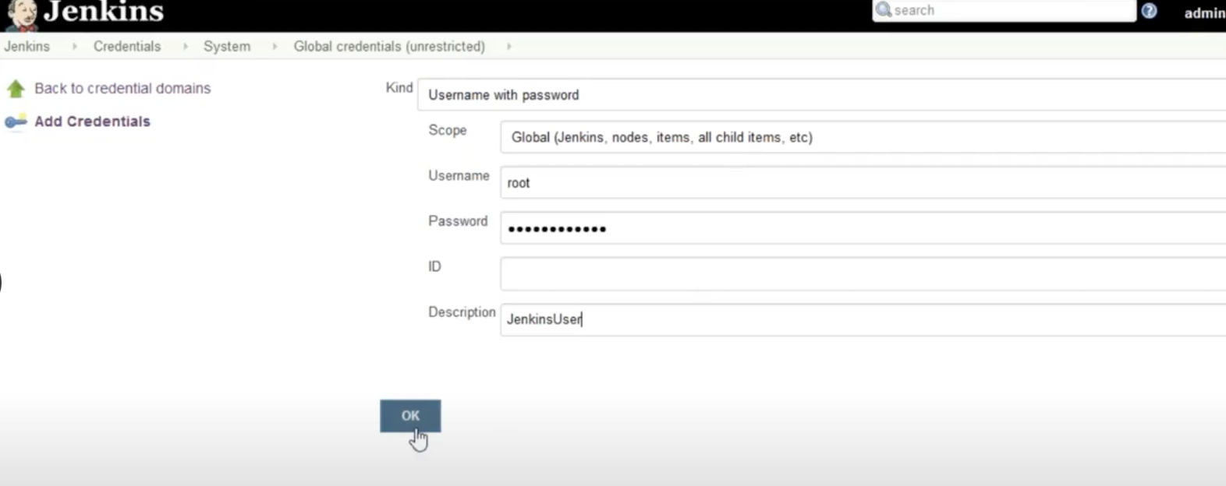

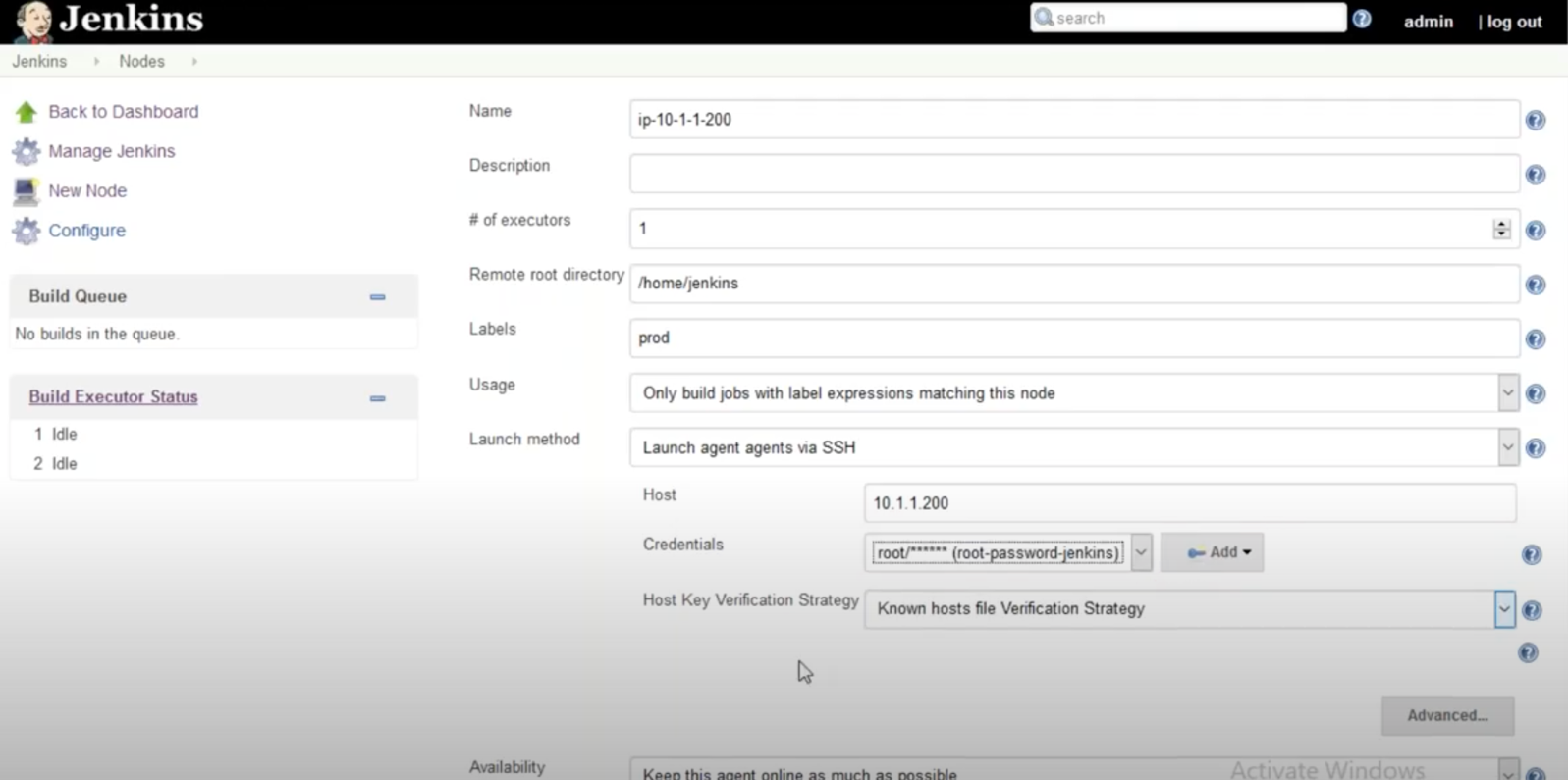

And save

Now when we give prod then jobs should be run on prod job

Now select Restrict where this project can be run

Jenkins pipeline

Jenkins Blueocen

JFrog Artifactory

1. Github clone repo
2. Unit test (sonarqube or junit)
3. Build -Create the war/jar using maven
4. Copy the artefact to the remote repository (JFrog)
5. Build a new Docker Image using the WAR/JAR created in ealier step.
6. Push the docker image to the docker registry (ECR,DockerHUB)
7. Deploy the container on the Docker swarm/Host/k8 cluster.
8. Check the application is reachable or not

Two types of piplines Declarative or scripted

Jenkins Docker integration

On Docker Host as below

Jenkins master must be installed on Docker engine we need to edit the docker host docker file to allow Jenkins server to run the images.

Nano /lib/system/system/docker.service and add following lines

To give permission

ExecStart=/usr/bin/docker -H unix:// -H tcp://0.0.0.2375 to deploy from Jenkins server we have to use 2375 port

systemctl daemon-reload

service docker restart

service docker status

now run this command curl <http://localhosts:2375/images/json> -----to confirm

by default Jenkins user will not have sudo permisions to execute to give jenkis acess

**on Jenkins server**

sudo usermod -a -G docker Jenkins

sudo service Jenkins restart

**if above don’t work**

usermod -aG root Jenkins

chmod 664 /var/run/docker.sock

chmod 777 /var/run/docker.sock

sudo service Jenkins restart

From the remote host run:

docker -H tcp://<DockerHost>:2375 ps

docker -H tcp://10.1.1.130:2375 ps

docker -H tcp://10.1.1.200:2375 run –rm dit –name jenkins2 –hostname jenkins2 ubuntu/Jenkins(image name)

## **What is ITIL?**

it standardizes the selection, planning, delivery, and support of IT services to maximize efficiency and maintain predictable levels of service

## **What are the ITIL Concepts?**

ITIL has several key principles that are realized through five core components. Some key ITIL concepts and principles are:

* + - Delivering maximum value to customers
    - Optimizing resources and capabilities
    - Offering services that are useful and reliable
    - Planning processes with specific goals in mind
    - Defining roles clearly for each task.

**Service now Ticketing**

**Break sicks incidents**

**Application support**

**Ntp sever ntp synch ntp clock**

Synchronize Time on Installed Linux Operating Systems

1. On the **Linux** machine, log in as root.
2. Run the **ntpdate** -u <**ntpserver**> **command** to update the machine **clock**. For example, **ntpdate** -u **ntp**-**time**. ...
3. Open the /etc/**ntp**. conf file and add the **NTP servers** used in your environment. ...
4. Run the service **ntpd** start **command** to start the **NTP** service and implement you configuration changes

How do I sync my NTP Server?

**To enable time synchronization with an NTP server, do the following:**

1. In the Use **NTP** to set clock window, click Yes. ...
2. In the Configure **NTP servers** window, select New. ...
3. In the **NTP server** field, enter the IP address or URL of the **NTP**, which you want to set the time **synchronization** with.
4. Click Ok. ...
5. Select Continue.

**To stop any particular services**

* Systemctl - sudo systemctl stop httpd
* Service - sudo service httpd stop

**How will u search particular services is running**

ps -ef | grep java

**ps aux | grep java**

**How do u shutdown server command**

**shutdown command** brings the system down in a secure way.

**Shutdown now – it will shutdown immediately**

**Tcp dump on that server**

tcpdump -i eth0 port 8801 -w a.pcap | nc 192.168.12.5 9901

**Linux servers logs – how can u find out issues in logs**

/var/log

 One of the most important **logs to** view is the syslog, which **logs** everything but auth-related messages.

$ dmesg | tail.

**What command u would be using the logs or analysing logs**

Sed Command

Grep,

Awak

Head /var/log.auth.log

**Issue yesterday we have to find out issue in logs to day**

Goto system logs and select by using date folder or logs

**My services is went down how do you capture the issue**

**(More command less command cat command)**

**What are the process are running how do u see**

**How do u kill process id**

**How to see how much usage on disk free**

$ sudo df -h presents data about your hard drives in a human-readable format

$ sudo df -hT shows both the amount of used space in your storage and its file system type.

**How do u change a owner ship of a file**

**How do u check how many files are there in particular server**

**How do u check kernel version and Linux version**